CHAPTER 22 – SOUND & MUSIC IN WINDOWS 🎵🖥️



History & Context

* **Early Multimedia:** Introduced as **Multimedia Extensions** in Windows 3.0 (1991), fully integrated in **Windows 3.1 (1992)**.
* **Hardware Adoption:** Sound cards, CD-ROM drives, and video support were rare in early 90s, now standard.
* **Impact:** Multimedia changed Windows from a **text & number platform** to a **rich media platform**—audio, video, games, and creativity became part of the OS.



2. Built-in Windows 10 Tools



**Windows Media Player:** Play audio/video files, manage playlists, organize libraries.

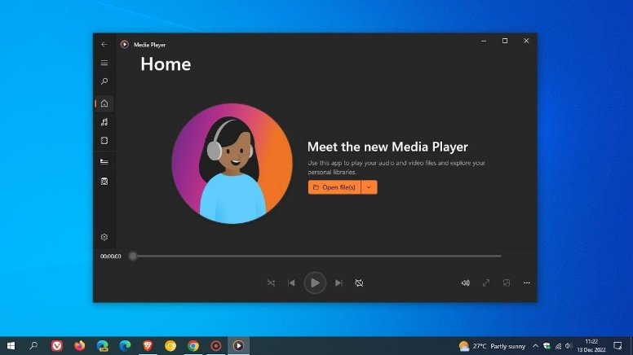

**Groove Music:** Stream music, play local files, create playlists, discover new music.

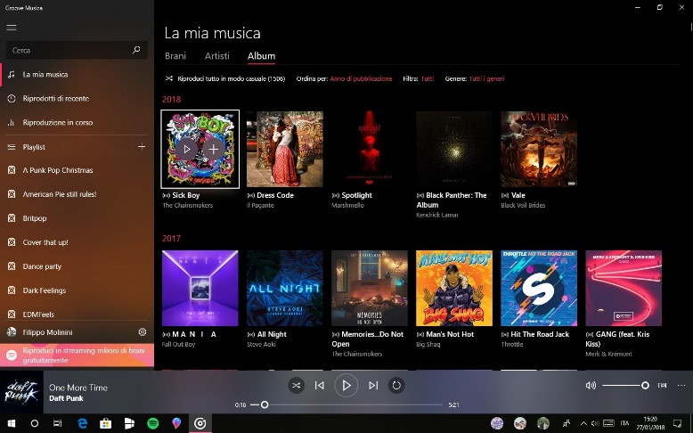

**Movies & TV:** Play videos, purchase/rent content, supports subtitles & casting.

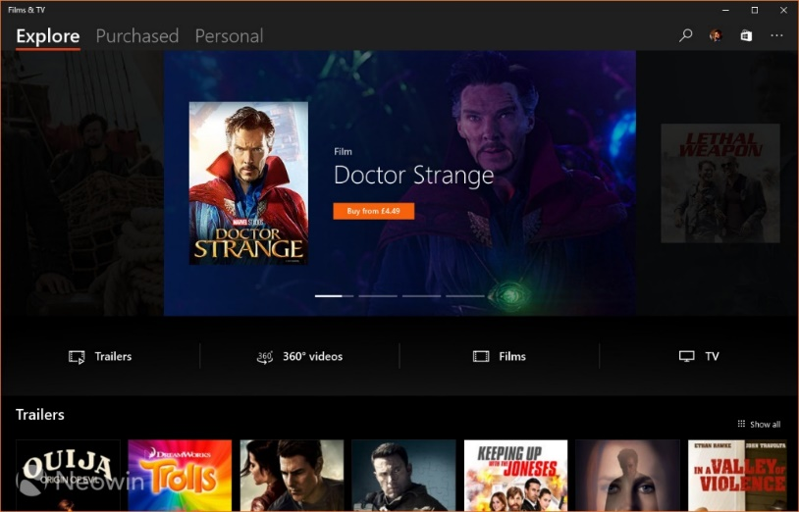

**Sound Settings:** Adjust volumes, configure devices, apply enhancements, set defaults.

* **Recording & Editing:**
  + **Voice Recorder** → Capture audio notes or interviews.
  + **Photos app** → Basic video editing (trim, add music, effects).
* **Gaming & Streaming:**
  + **Xbox App & Game Bar** → Capture gameplay, stream games, manage audio.
* **Virtual/Mixed Reality:** Windows Mixed Reality platform for VR/360 content.



3. Core Multimedia Capabilities

Device-Independent Multimedia API

**Purpose:** Abstract hardware details so apps work across different devices.

**Supported hardware:**

* **Waveform Audio Devices (Sound Cards)**
  + Convert analog ↔ digital audio, store in .WAV files, play through speakers.
* **MIDI Devices**
  + Musical Instrument Digital Interface. Produce notes via keyboards or synthesizers.
* **CD-ROM Drives (CD Audio)**
  + Play standard audio CDs directly.
* **Video for Windows (AVI)**
  + Software playback for AVI files, can use hardware acceleration.
* **ActiveMovie Control**
  + Expand playback to QuickTime, MPEG; hardware acceleration supported.
* **Laserdisc Players & VISCA Video Cassettes**
  + Controlled via serial interface for PC-driven playback.



Key Concepts

* **Device Abstraction:** Write once, works on any hardware. The API hides device-specific details.
* **Hardware Mixing:** Combine multiple audio sources (wave, MIDI, CD) in **Volume Control**, adjust relative volumes.
* **Hardware Acceleration:** Video boards speed up movie rendering; smoother playback.
* **Serial Interface Control:** Control devices like laserdiscs via PC commands.

4. Evolution & Importance

* **1991 → Now:** Multimedia moved from optional extensions to core part of Windows.
* **Standardization:** Sound cards, CD-ROMs, and video boards became ubiquitous.
* **User Experience:** Multimedia enriches interfaces—beyond text/numbers to **immersive, interactive computing**.

5. WinAPI Takeaways

* Windows provides a **consistent API** for audio, MIDI, CD audio, and video, making **cross-hardware apps possible**.
* Supports both **hardware-accelerated** and **software-based** multimedia.
* Modern Windows (10+) combines **playback, recording, editing, gaming, VR/AR** under a unified multimedia strategy.
* Multimedia isn’t just a “feature”—it’s a **platform-level layer** that transforms how users interact with their computers.

6. Summary

* **Windows Multimedia = Standard Today:** CD, audio, MIDI, AVI, VR.
* **APIs abstract hardware:** Apps don’t need to know exact sound card or video board.
* **User impact:** Windows went from number crunching to entertainment, productivity, and immersive experiences.
* **WinAPI lesson:** Multimedia APIs are a perfect example of **device abstraction, hardware acceleration, and modular hardware support**.

MULTIMEDIA API DESIGN IN WINDOWS **🎶🖥️** (PART 2)

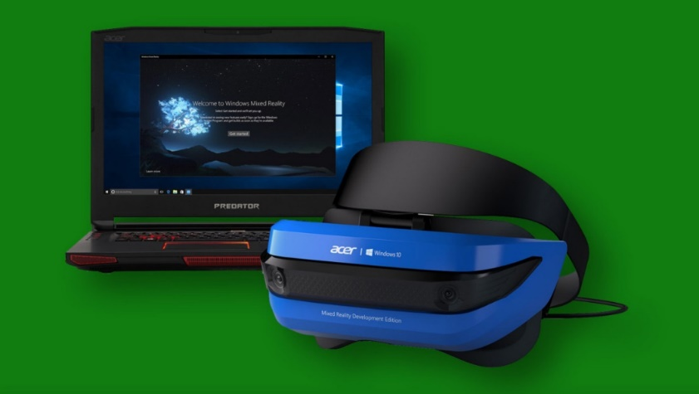

1. Strategic API Design – The Dual-Layer Approach

Windows organizes its multimedia APIs in **two layers**, each with a clear purpose:

Low-Level Interfaces

* **Purpose:** Direct, fine-grained control over hardware.
* **Pros:** Maximum flexibility, precision, and optimization.
* **Cons:** More complex, requires deeper programming knowledge.
* **Examples & Use Cases:**
  + **Waveform Audio:** waveIn & waveOut → record/playback digital audio (voices, music, sound effects).
  + **MIDI:** midiIn, midiOut, midiStream → control synthesizers, keyboards, and music sequencing.
  + **Timing:** time functions → high-resolution timers for syncing audio/video and MIDI events.

High-Level Interfaces

* **Purpose:** Simplify development for common tasks.
* **Pros:** Faster to develop, easier to read/maintain code.
* **Cons:** Less control, limited fine-tuning.
* **Key Example: MCI (Media Control Interface)**
  + **String-Based Commands:** Control multiple devices (audio, video, CD-ROM) via simple textual commands.
  + **Rapid Prototyping:** Perfect for experiments or scripting small multimedia projects.
  + **Device Coverage:** Audio, video, optical media—basically a unified interface for most consumer multimedia.

2. Beyond the Core – Expanding Possibilities

DirectX API

* **Purpose:** Hardware-accelerated multimedia for games and graphics-intensive apps.
* **Features:**
  + 3D graphics rendering
  + Advanced audio processing
  + Robust input support (controllers, VR devices)
* **Usage:** While not deep in this chapter, DirectX is the **go-to for performance-heavy multimedia apps**, especially games.

Convenient Utilities

* **MessageBeep:** Quick sound alerts for UI feedback.
* **PlaySound:** Simplifies playing sound effects or music in apps.
* **Use Case:** Great for adding **immediate audio feedback** without dealing with complex APIs.

3. Key Considerations When Choosing APIs

Project Requirements:

* Real-time audio? Go low-level.
* Simple playback? High-level MCI is enough.

Developer Expertise:

* Low-level APIs require understanding buffers, timing, and device interfaces.
* High-level APIs work for most general apps with standard functionality.

Target Hardware:

* Know your sound cards, MIDI devices, and video capabilities.
* Some APIs (like DirectX) leverage advanced hardware acceleration, while others are software-based.

4. TLDR

Windows gives **two tiers** of multimedia APIs:

* **Low-Level:** Maximum control & performance (wave, MIDI, time).
* **High-Level:** Fast, easy, versatile (MCI, PlaySound, MessageBeep).

**DirectX:** Extra power for graphics/audio-heavy apps.

**Choice matters:** Base it on **project needs, dev skill, and hardware**.

TESTMCI PROGRAM



Chapter 22 – TESTMCI Program & MCI Commands 🎵 (Part 3)

1. What TESTMCI Really Does

* It’s an **interactive playground for MCI commands**.
* You type in commands, hit Enter/OK, and Windows runs them via **mciSendString**.
* Responses go to the **Return String** box, and errors are nicely translated with **mciGetErrorText**.
* Multiple selected lines? Each one runs in sequence—like mini scripts.

**TLDR:** It’s a **live MCI console** with GUI feedback. Think of it as a “CD player + MCI debugger in one window.”

2. Core Functions

**mciSendString**

* Sends a textual MCI command to the system.
* Examples:
  + open cdaudio → open the CD drive
  + play cdaudio → start playback
  + status cdaudio length → get total CD length

**mciGetErrorText**

* Converts numeric MCI error codes into readable text.
* Displays errors in the **Error String** section so you know what went wrong.

3. CD Audio Control

* Control a real CD drive with commands like:
  + pause cdaudio, stop cdaudio → simple playback controls
  + play cdaudio from 2:30 to 3:00 → play specific time ranges
* Can query: total tracks, track lengths, and time formats (msf, tmsf).

4. Timing & Options

* **wait:** command blocks until it finishes.
* **notify:** sends an MM_MCINOTIFY message when done.
* **break:** safety net if wait is stuck too long.
* **Scripting:** Select multiple lines → batch execution → mini automation.

**Pro Tip:** Combining wait + notify is possible, but mostly unnecessary. One is usually enough.

5. Potential Applications

* Build a **mini-CD player UI**: display track info, play/pause, show a timer.
* **Sync graphics with music:** for instruction software or small visualizers.
* Automation of repeated tasks with **MCI scripts**.

6. Bottom Line

TESTMCI is a **hands-on MCI lab**.

* It **teaches by doing**, not just reading.
* You can experiment, batch commands, see errors in real time.
* Overexplaining the GUI and buffers is kinda moot—the **magic is in typing commands and watching Windows respond**.

Chapter 22 – Waveform Audio in Windows **🎵** (Part 4)



1. Waveform Audio Basics

* **Waveform audio = foundation of Windows sound**.
* Converts **analog vibrations → digital samples** → stored as .WAV files.
* Enables **recording, processing, playback**.

**Real-world analogy:** Microphone captures air pressure changes → Windows digitizes them → you can play them back or manipulate them.

2. Sound 101

* **Sound = vibration** perceived as air pressure changes hitting eardrums.
* **Analog storage:** tapes, records → vibrations stored as magnetic or physical patterns.
* **Digital storage:** digitized waveforms in .WAV files.

Key Parameters:

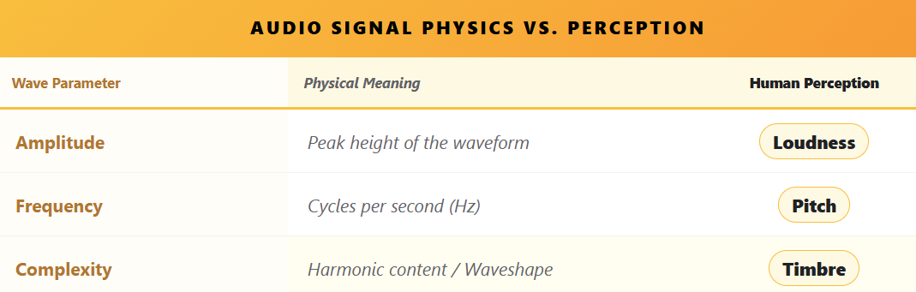

* Humans hear roughly **20 Hz – 20 kHz**, but higher frequencies fade with age.
* Human frequency perception is **logarithmic**, not linear → doubling frequency = octave.
* Piano spans ~7 octaves (27.5 Hz – 4186 Hz).

3. Complexity of Real Sounds

* **Pure sine waves = boring sounds**.
* Real sounds = mix of **multiple harmonics** (Fourier series).
  + Fundamental frequency = base pitch.
  + Harmonics = integer multiples of fundamental → define **timbre**.
* **Timbre = why a piano sounds different from a trumpet**.
  + Requires at least 1 fundamental + 7 harmonics.
  + Harmonics intensity varies across notes and instruments.

**Attack & Dynamic Harmonics**

* First part of a note (attack) = crucial for recognizing timbre.
* Harmonics evolve dynamically → making **synthesis non-trivial**.

4. Digital Audio Representation

* Advancements in **digital storage** allow **direct digital capture**.
* Instead of reconstructing sound from sine waves, we **store rich, complex sounds** as-is.
* Enables:
  + Accurate instrument reproduction
  + Efficient playback & editing
  + Complex audio applications in Windows

5. Windows Waveform Audio API

* Provides functions to:
  + **Capture audio** (from mic or line-in)
  + **Store digitally** (memory or disk)
  + **Playback** through speakers or other outputs
* Forms the backbone of audio apps in Windows: **voice recorders, games, music software, and more**.

**TLDR:** Waveform audio in Windows isn’t just “play .WAV files.” It’s the **digital bridge between real-world sound physics and software manipulation**.

From sine waves → harmonics → timbre → digital storage, understanding this makes you **ready to leverage the Waveform API efficiently**.

Chapter 22 – Pulse Code Modulation (PCM) & Sampling

1. PCM: Bridging Analog Sound & Digital Computers

* **Analog sound** = smooth, continuous waves.
* **Digital computers** = discrete numbers only.
* **PCM (Pulse Code Modulation)** = method for converting analog waves → digital numbers → back to sound.
* **Steps:**
  1. **Sampling:** Take snapshots of the sound wave at regular intervals.
  2. **Quantization:** Convert snapshots into numbers with a set bit depth.
  3. **Digital Storage:** Store as .WAV or memory buffer.
  4. **Playback:** Use DACs + smoothing filters to reconstruct a clean analog waveform.

**Analogy:** Think of a sound wave as a rolling hill. Sampling = taking photos along the hill; quantization = marking the height of each photo in numbers; DAC + filter = sculpting a smooth hill back from the numbers.

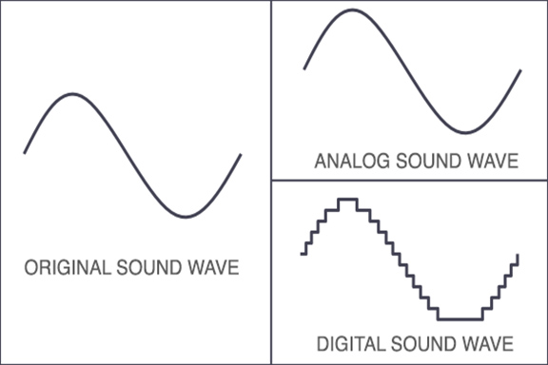

2. Sampling Rate & Sample Size

* **Sampling Rate (Hz):** How often you “take a snapshot” of the waveform per second.
  + **CD-quality:** 44.1 kHz → captures full human hearing range (~20 Hz–20 kHz).
  + Lower rates (22.05 kHz, 11.025 kHz, 8 kHz) = smaller file sizes, less detail (good for voice or telephony).
  + **Nyquist Rule:** Must be ≥ 2 × highest frequency to avoid distortion.
  + **Aliasing:** Occurs if sampling too slow → creates fake, unwanted frequencies. Prevented with **low-pass filters**.
* **Sample Size (bits):** How precise each snapshot is.
  + Larger = more detail (like high-res photos of sound).
  + Smaller = less detail, noisier approximation.

**Teen-Friendly Tip:**

* Sampling rate = **how often you take pictures of the sound**.
* Sample size = **how many pixels each picture has**.

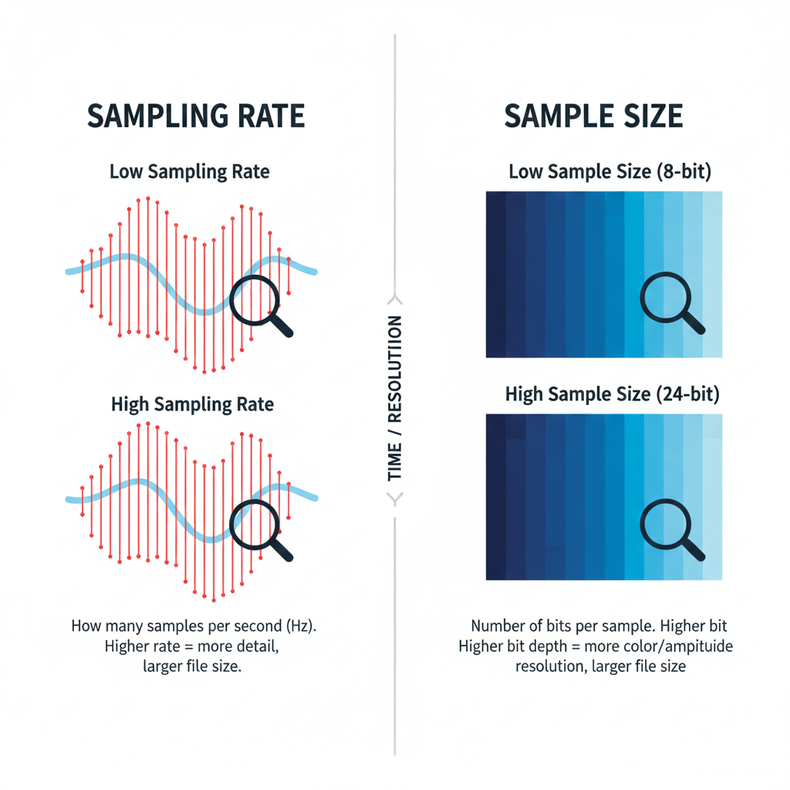

3. Overtones & Timbre

* Real sounds ≠ single sine wave; instruments produce **harmonics (overtones)**.
* **Fundamental frequency:** main pitch.
* **Overtones:** integer multiples of fundamental → create richness & character (timbre).
* Low sampling rates can **miss overtones**, making sound thin or flat.

**Analogy:**

* Fundamental = main ingredient in a recipe.
* Overtones = spices/flavors.
* Capture both → tasty/full music; capture only fundamental → bland music.

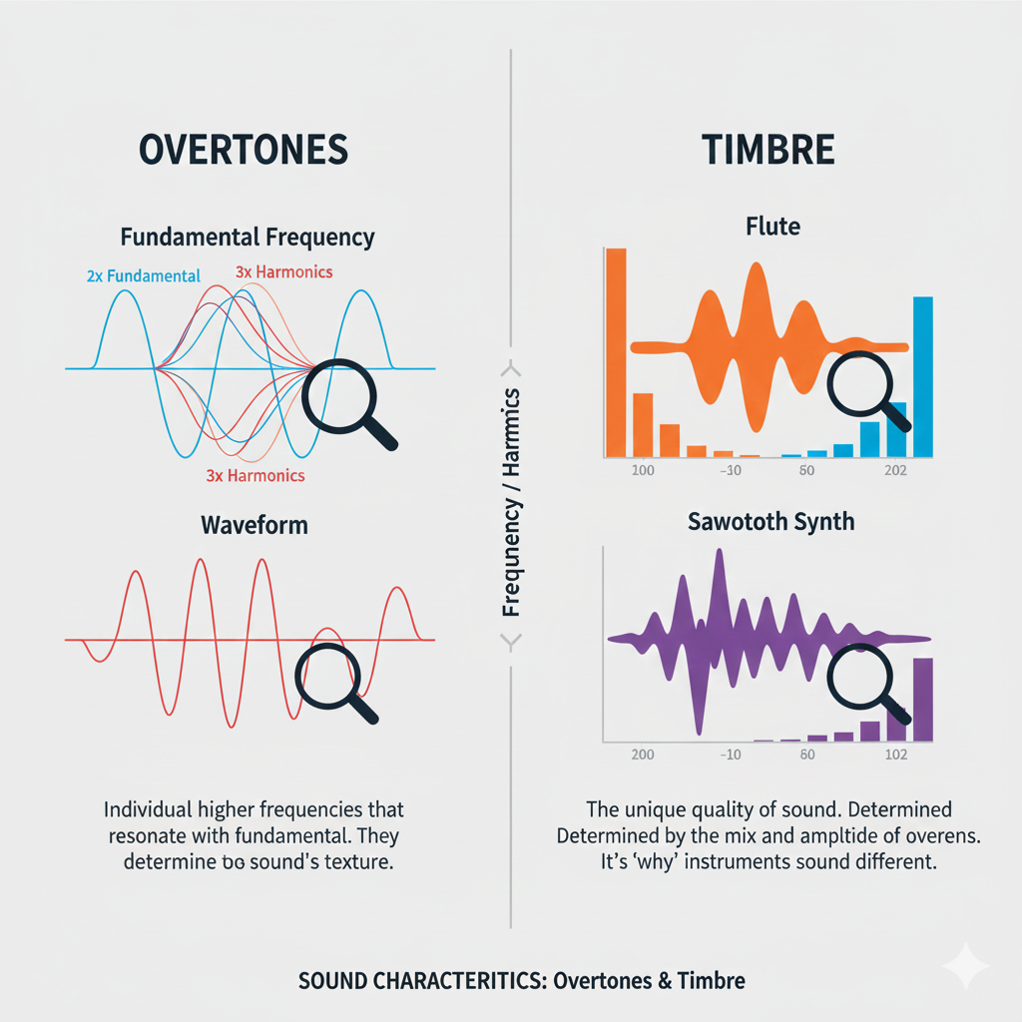

4. Key Takeaways for PCM & Windows Audio

* Sampling rate & sample size = **digital audio quality drivers**.
* **Nyquist frequency** sets minimum sample rate to avoid aliasing.
* **Low-pass filters** prevent digital artifacts.
* Overtones are essential for **true musical richness**.
* Choosing the right balance = **efficient, high-quality audio**.

💡 **Pro tip for coding in Windows:** When using waveIn* or waveOut* APIs, you’ll often configure **sampling rate, bits per sample, and channels**. Understanding PCM is critical because these parameters determine whether your recording/playback is crisp, faithful, or just noise.

SAMPLE SIZE: CAPTURING SOUND’S DYNAMIC RANGE

Measuring Sound Detail

Sample size (measured in bits) controls how much detail we can capture in sound. It decides how accurately a digital system can represent quiet sounds and loud sounds.

In short, it defines the **dynamic range** — the distance between the softest and loudest audio we can record without distortion.

More Bits, More Detail

Each extra bit doubles the number of possible volume levels. This gives the system more precision when recording sound.

Think of it like painting: more bits mean more shades of color, so the final picture sounds smoother and more realistic.

Decibels: Measuring Loudness

Why Decibels Are Used

Human hearing does not work in a straight line. We notice small changes in quiet sounds more easily than changes in loud sounds. Because of this, sound intensity is measured on a **logarithmic scale**, called decibels (dB).

Bels and Decibels

The bel is named after Alexander Graham Bell.

* One bel means the sound intensity increased ten times.
* A decibel is one-tenth of a bel and represents a very small but noticeable change in loudness (about 1.26 times louder).

This scale matches how our ears actually hear sound.





Calculating Dynamic Range

The dynamic range between two sounds is measured in decibels using this formula:

**Dynamic Range (dB) = 20 × log₁₀ (Maximum Amplitude / Minimum Amplitude)**

In digital audio systems, dynamic range depends directly on sample size (number of bits).  
More bits allow a bigger difference between the quietest and loudest sounds. A common rule is:

**Dynamic Range (dB) ≈ 6 × Number of Bits**

So:

* 8-bit audio ≈ 48 dB
* 16-bit audio (CD quality) ≈ 96 dB
* 24-bit audio ≈ 144 dB

Storage Space for Uncompressed Audio

To calculate how much storage uncompressed audio needs, we use this formula:

**Storage = Sample Rate × Bit Depth × Number of Channels × Duration**

For example:  
One hour of CD-quality audio:

* 44,100 samples per second
* 16 bits per sample
* Stereo (2 channels)

This requires about **635 megabytes**, which is roughly the capacity of a standard audio CD.



Final Takeaway

Higher bit depth means:

* Better dynamic range
* More accurate sound
* Larger file sizes

So, the better the sound quality, the more storage space we need to preserve all those musical details 🎵

Common Sample Sizes and What They Mean

8-bit Audio

8-bit audio has a dynamic range of about **48 dB**.  
This means it can represent only a small range between quiet and loud sounds.

**Think of it like a small box of crayons.**  
You can draw the picture, but the sound is rough and blocky.  
It’s good enough for:

* Simple voice recordings
* Old games
* Basic sound effects

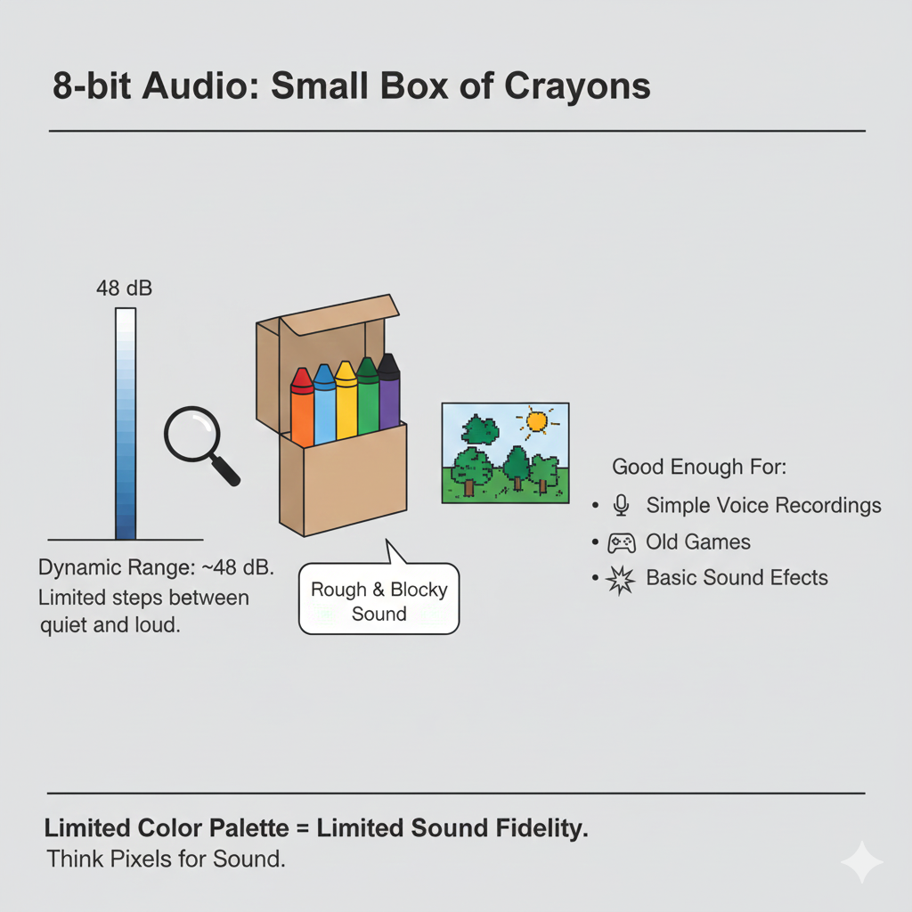

16-bit Audio

16-bit audio has a dynamic range of about **96 dB** and is the standard for CDs and most consumer audio.

**This is like a full box of crayons.**  
You get smooth sound with enough detail to handle:

* Quiet whispers
* Loud music
* Strong drum hits

For most listening, 16-bit audio already sounds very clean and natural.

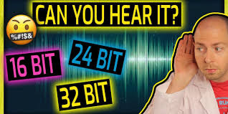

24-bit Audio

24-bit audio offers a huge dynamic range of about **144 dB** and is used in professional recording studios.

**This is like having professional paint instead of crayons.**  
It captures extremely tiny sound details and leaves extra “headroom” so engineers can edit, mix, and process audio without distortion.

Most people can’t hear the full range, but it’s perfect for recording and editing before the final version is made.

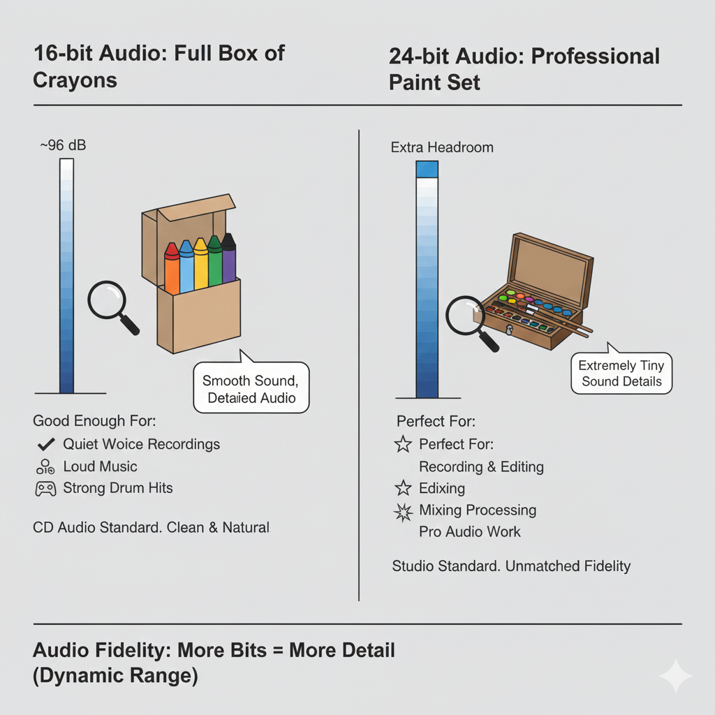

Storage and How Audio Data Is Stored

How Samples Are Stored in Windows

Windows commonly supports:

* **8-bit samples** stored as *unsigned bytes*
* **16-bit samples** stored as *signed integers*

You don’t need to memorize this, just understand the idea:  
different bit sizes use different number formats to store sound levels.

How Silence Looks in Data

Silence is not always stored as “nothing.”

* In **8-bit audio**, silence is stored as the value **0x80** (the middle of the range).
* In **16-bit audio**, silence is stored as **all zeros**.

**Think of silence as the “center line” of a waveform.**  
No movement above or below that line means no sound.

How Much Space Uncompressed Audio Needs

Several things decide how big an audio file will be:

* How long the sound is
* How many samples are taken each second (sample rate)
* How many bits each sample uses (bit depth)
* How many channels there are (mono or stereo)

**Simple idea:**  
More samples + more bits + more channels = bigger files.

Real-World Example

One hour of CD-quality audio:

* 44,100 samples per second
* 16 bits per sample
* Stereo (2 channels)

This needs about **635 megabytes** of storage.

**Think of it like taking photos:**  
Higher resolution photos look better, but they take up more space.  
Audio works the same way.

Big Picture Takeaway

* Higher bit depth = better sound detail
* Better sound detail = more storage space
* Choose what fits your needs: quality vs file size

Generating Sine Waves in Windows **🎶**

1. Core Concept

* Digital audio uses **PCM (Pulse Code Modulation)**.
* The sin function from math.h generates sine wave values.
* **Phase angle** ensures smooth, continuous waves—never let it jump suddenly, or you get clicks/glitches.

2. Workflow of the Sine Wave Generator

1. **Set sample rate:** e.g., 11,025 Hz.
2. **Set frequency:** user-controlled (iFreq).
3. **Calculate samples per cycle:** samplesPerCycle = sampleRate / frequency.
4. **Fill buffer:** for each sample, compute amplitude = sin(phaseAngle) * maxAmplitude.
5. **Increment phase angle:** phaseAngle += 2 * PI * frequency / sampleRate.
6. **Wrap phase angle:** subtract 2*PI if it exceeds 2π.
7. **Double-buffer playback:** pBuffer1 & pBuffer2 keep audio continuous without gaps.

3. Windows Waveform Audio API

* waveOutOpen: Opens audio device, specifying device ID (WAVE_MAPPER) and waveform format (WAVEFORMATEX).
* waveOutPrepareHeader: Prepares buffers so they won’t be swapped to disk.
* waveOutWrite: Sends buffer to hardware for playback.
* waveOutReset: Stops playback immediately.
* **Double-buffering & MM_WOM_DONE messages** = seamless audio streaming.

4. User Interface

* **Scroll bar:** Adjust frequency in real-time (20 Hz → 5000 Hz).
* **Text box:** Displays frequency, allows manual input.
* **On/Off button:** Starts/stops playback.

**Interactive magic:** move scroll bar → instantly hear frequency change.

5. Waveform Format & Buffers

* WAVEFORMATEX defines: sample rate, bits per sample, channels, block alignment.
* WAVEHDR defines: buffer pointer, buffer length, loops, flags.
* Use **double-buffering** to continuously feed the audio device.

**Tip:** dwLoops = 1 → repeat once per buffer, handled by the API via MM_WOM_DONE.

6. Messages & Cleanup

* **MM_WOM_OPEN:** Device ready → fill buffers and start playback.
* **MM_WOM_DONE:** Hardware finished buffer → refill & write next buffer.
* **MM_WOM_CLOSE:** Device closed → free buffers, reset UI.
* **WM_SYSCOMMAND (SC_CLOSE):** Graceful shutdown if user closes window.

**Result:** smooth, continuous, adjustable sine wave playback with interactive control.

7. Key Takeaways

* Double-buffering + phase management = **no audio glitches**.
* Real-time frequency adjustment = **interactive experience**.
* Proper WAVEFORMATEX and WAVEHDR setup = **stable playback**.
* Messages (MM_WOM_*) = **audio device feedback loop**.

The cool part here is that this approach is **literally everything you need to build a mini synthesizer or a test tone generator** in Windows.

Once you fully grasp double-buffering + MM_WOM_DONE + phase continuity, you can make **any waveform, not just sine waves**—triangles, squares, even complex harmonics. 🎛️



RECORD.C – Windows Audio Recording & Playback **🎤🎶**

1. Program Initialization

* **Headers included:** windows.h + resource.h.
* **Memory allocated:**
  + pWaveHdr1, pWaveHdr2 → wave headers for audio buffers.
  + pSaveBuffer → stores recorded audio.
* **Platform check:** Windows NT? Then show main dialog.
* **WinMain:** Entry point, sets up everything.

2. Utility: ReverseMemory

* Reverses audio data in a buffer → enables **reverse playback**.
* Swaps bytes from start ↔ end of buffer.
* Simple but essential for creative playback features.

3. Dialog Procedure (DlgProc)

Handles **all UI + audio logic** via messages (WM_COMMAND, MM_WIM_DATA, MM_WOM_DONE, etc.).

4. Recording Flow

**Trigger:** Press “Record Begin” (IDC_RECORD_BEG)

**Steps:**

1. **Allocate input buffers:** pBuffer1 and pBuffer2 (size INP_BUFFER_SIZE).
2. **Open audio input:** waveInOpen with WAVEFORMATEX for format, hwnd for callbacks.
3. **Prepare wave headers:** waveInPrepareHeader.
4. **Start recording:** waveInAddBuffer + waveInStart.

**Data Handling (MM_WIM_DATA):**

* Reallocate pSaveBuffer via realloc to store incoming data.
* Copy current buffer data into pSaveBuffer.
* If ending (bEnding=TRUE) → waveInClose; else, queue next buffer.

**End Recording (IDC_RECORD_END):**

* Set bEnding = TRUE.
* waveInReset stops recording, flushes last buffer → triggers MM_WIM_DATA.
* waveInClose frees resources, enables/disables buttons.

5. Playback Flow

**Trigger:** Press “Play Begin” (IDC_PLAY_BEG)

**Steps:**

1. Initialize WAVEFORMATEX with sample rate, channels, bits/sample.
2. Open audio output device: waveOutOpen.
3. Prepare header with pSaveBuffer: waveOutPrepareHeader.
4. Start playback: waveOutWrite.

**Data Handling (MM_WOM_DONE):**

* Playback finished → unprepare header + waveOutClose.
* If bReverse=TRUE → call ReverseMemory for next reverse playback.

**End Playback:** System closes properly via MM_WOM_CLOSE.

6. Playback Enhancements

* **Pause/Resume:** waveOutPause / waveOutRestart.
* **Reverse:** ReverseMemory.
* **Repeat:** Set dwLoops and dwFlags in WAVEHDR.
* **Speedup:** Adjust nSamplesPerSec and nAvgBytesPerSec in WAVEFORMATEX → doubles playback speed.

7. Memory & Resource Management

* Memory allocated for:
  + Input buffers (pBuffer1, pBuffer2)
  + Save buffer (pSaveBuffer) → dynamically resized during recording.
* Freed during:
  + MM_WIM_CLOSE, MM_WOM_CLOSE, program exit.
* Efficient handling ensures **no leaks** during extended recording/playback sessions.

8. Key Insights

* **Double-buffering** ensures smooth continuous audio capture and playback.
* **MM_WIM_DATA / MM_WOM_DONE** = backbone of async handling for audio devices.
* **WAVEFORMATEX + WAVEHDR** = central structures for all waveform audio operations.
* **Reverse / Repeat / Speedup / Pause / Resume** = shows power & flexibility of the Windows Waveform API.

💡 TLDR:  
RECORD.C is basically a **mini DAW in a dialog box**. It captures audio, allows playback, pause, reverse, repeat, and speed adjustment—all via low-level waveform API. If you nail MM_WIM_DATA, MM_WOM_DONE, double-buffering, and ReverseMemory, you’ve got full control of real-time digital audio in Windows.

Windows Audio Programming – RECORD1 → RECORD3 **🎧**

1. Low-Level Waveform API (RECORD1)

**Mechanism:**

* Direct hardware access via waveInOpen, waveOutOpen, waveInAddBuffer, waveOutWrite.
* Double-buffering (pBuffer1/pBuffer2) + dynamic pSaveBuffer for recording.
* Handles audio at byte level → supports effects like **reverse, repeat, speedup, pause/resume**.

**Message Handling:**

* WM_COMMAND → buttons: record, play, pause, stop.
* MM_WIM_DATA → recorded buffer available.
* MM_WOM_DONE → playback finished.

**Pros:** Fine-grained control → special effects, low-latency recording/playback.

**Cons:** Complex: memory management, buffer handling, messages, headers.

2. Message-Based MCI (RECORD2)

**Mechanism:**

* File-based audio: records to .wav files.
* Controls device via mciSendCommand(wDeviceID, command, flags, params).
* Key commands: MCI_OPEN, MCI_RECORD, MCI_STOP, MCI_SAVE, MCI_PLAY, MCI_PAUSE, MCI_CLOSE.
* MM_MCINOTIFY messages used to track completion: MCI_NOTIFY_SUCCESSFUL or MCI_NOTIFY_ABORTED.

**Workflow:**

* Record Begin → MCI_OPEN + MCI_RECORD.
* Record End → MCI_STOP → MCI_SAVE → MCI_CLOSE.
* Playback → MCI_OPEN file → MCI_PLAY.
* Pause/Resume → MCI_PAUSE / MCI_PLAY.

**Pros:**

* Simpler: no manual buffer management.
* Automatic file storage and retrieval.
* Built-in notifications for operation completion.

**Cons:**

* File-based → no real-time effects (reverse, speedup).
* Slightly slower than low-level API for intensive processing.

3. MCI String Approach (RECORD3)

**Mechanism:**

* Uses **text commands** (mciSendString / mciExecute) instead of message structs.
* Examples:

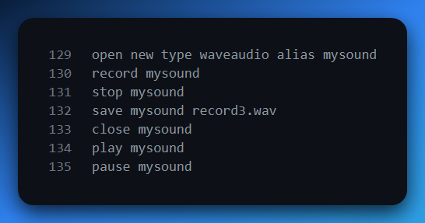

* Alias allows referencing device by name rather than ID.

**Workflow:**

* Record → delete existing file → open → record.
* Stop → stop → save → close.
* Play → open file → play.
* Pause/Resume → pause / play.

**Differences from RECORD2:**

* No MM_MCINOTIFY → program doesn’t auto-detect completion.
* Buttons must be manually clicked for end-of-playback/recording actions.
* Encapsulated error handling via mciExecute (returns Boolean).

**Pros:**

* Very concise, readable code.
* Easier for scripting, command-line style, and cross-Windows versions.

**Cons:**

* Less control over device (no real-time processing).
* No automatic state management → user must manually end operations.
* Limited to MCI-supported formats and features.

4. Key Differences Across RECORD1 → RECORD3

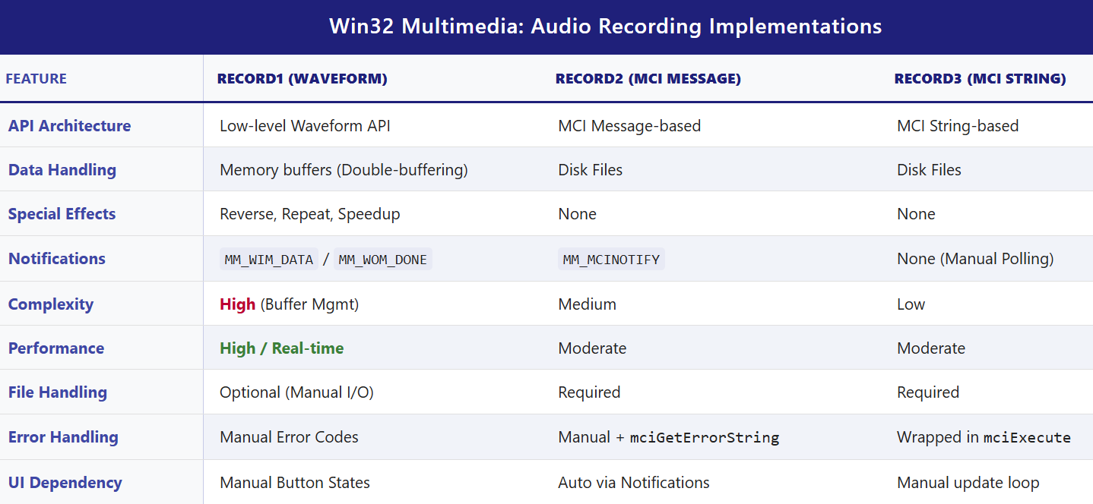

**5. Practical Notes / Takeaways**

* **Low-Level API** → use for learning, special effects, or real-time audio apps.
* **Message-Based MCI** → good for standard record/play apps with simple automation.
* **String-Based MCI** → easiest to code, readable, cross-Windows, but loses automation and effects.
* **MCI String Examples in real apps:**
  + Simple audio players (Windows Media Player classic UI).
  + Voice recorders or note apps.
  + Lightweight VoIP or chat apps (older Windows platforms).
* **Limitations of MCI String Approach:**
  + Limited control and effects.
  + Performance not optimal for live processing.
  + Windows-only, older tech (not updated for modern audio features).

Waveform Audio File Format:

Delving into the uncompressed (PCM) .WAV files reveals a specific format, as outlined in Figure 22-6.



Each section of the file is delineated by offsets and consists of various data components.

The "RIFF" chunk signifies the beginning of the file, followed by information such as the size of the waveform chunk, "WAVE" identifier, and details about the format chunk.

Key parameters in the format chunk include the audio format tag, number of channels, sample rate, average bytes per second, block alignment, and bits per sample.

The "data" chunk encapsulates the actual waveform data. Understanding this file format is crucial for working with .WAV files programmatically.

Drawbacks of MCI Execute Function in RECORD3:

While RECORD3 benefits from the simplicity of the mciExecute function, it faces a drawback in not being informed of the completion of waveform file playback.

The absence of MM_MCINOTIFY messages means that the program cannot dynamically update button states based on playback status.

This limitation requires users to manually signal completion by pressing the "End" button.

RIFF FORMAT AND WAVEFORM AUDIO FILE STRUCTURE:

The RIFF (Resource Interchange File Format) serves as an extensive format for multimedia data files, utilizing a tagged file structure composed of identifiable chunks.

Each chunk is denoted by a preceding 4-character ASCII name and a 4-byte chunk size, excluding the 8 bytes required for the chunk name and size. This format ensures a modular and extensible approach to organizing data within a file.

A waveform audio file, following the RIFF format, begins with the "RIFF" identifier, indicating its RIFF nature.

The subsequent 32-bit chunk size signifies the size of the remaining file, excluding the initial 8 bytes.

The actual chunk data starts with the "WAVE" identifier, designating it as a waveform audio chunk.

Following this, the "fmt " identifier (note the trailing blank for a 4-character string) signals a sub-chunk containing the format information of the waveform audio data.

The "fmt " sub-chunk is accompanied by the size of the format information, typically 16 bytes. This information corresponds to the first 16 bytes of the WAVEFORMATEX structure or, as originally defined, a PCMWAVEFORMAT structure incorporating a WAVEFORMAT structure. Key parameters in this structure include:

* nChannels: Indicates whether the audio is monaural (1 channel) or stereo (2 channels).
* nSamplesPerSec: Denotes the number of samples per second, with standard values like 11025, 22050, and 44100 samples per second.
* nAvgBytesPerSec: Represents the sample rate in samples per second multiplied by the number of channels and the size of each sample in bits, divided by 8 and rounded up.
* nBlockAlign: Signifies the number of channels times the sample size in bits, divided by 8 and rounded up.
* wBitsPerSample: Specifies the number of channels times the sample size in bits.

Following the format information, the sub-chunk concludes with the "data" identifier, succeeded by a 32-bit data size and the actual waveform data.

The data consists of consecutive samples, mirroring the format used in low-level waveform audio facilities.

For sample sizes of 8 bits or less, each sample is either 1 byte for monaural or 2 bytes for stereo.

If the sample size ranges from 9 to 16 bits, each sample is 2 bytes for monaural or 4 bytes for stereo. In stereo waveform data, each sample contains the left value followed by the right value.

Despite the necessary inclusion of "fmt " and "data" sub-chunks in a waveform audio file, additional sub-chunks, like "INFO," may coexist.

These sub-chunks can contain further information about the waveform audio file, emphasizing the flexibility and extensibility of the RIFF format.

One critical rule when dealing with tagged files is to ignore chunks that are not relevant or prepared for processing.

This ensures robust handling of files with varying structures, focusing only on the essential sub-chunks for waveform audio data.

Understanding the intricacies of the RIFF format provides valuable insights into how multimedia data, particularly audio, is organized within files. This knowledge is foundational for developers and enthusiasts working with audio file manipulation and processing.

EXPLORING ADDITIVE SYNTHESIS AND TIMBRE IN MUSICAL TONES:

Analyzing musical tones involves understanding fundamental elements such as pitch, volume, and the complex characteristic known as timbre.

Pitch refers to the frequency of a musical tone, spanning the human perceptual spectrum from 20 Hz to 20,000 Hz. For instance, the notes of a piano cover a frequency range from 27.5 Hz to 4186 Hz.

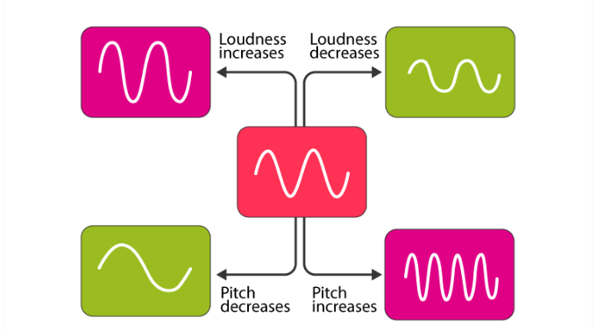

Volume or loudness, indicating the overall amplitude of the waveform generating the tone, is measured in decibels. While pitch and volume seem straightforward, the concept of timbre adds complexity.

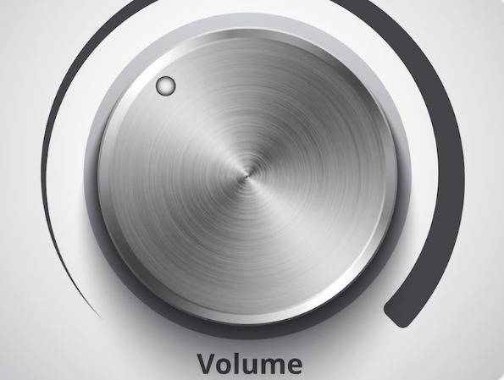

Timbre is the quality of sound that allows us to differentiate between instruments playing the same pitch at the same volume. It's the distinctive sonic fingerprint that separates a piano from a violin or a trumpet.

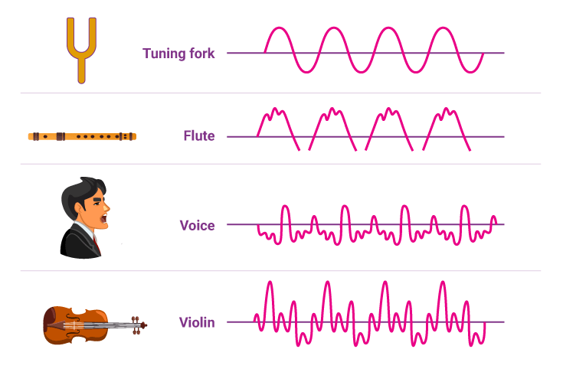

The mathematical insights of Fourier further illuminate the intricacies of sound. Fourier discovered that any periodic waveform, regardless of complexity, can be expressed as a sum of sine waves.



These sine waves have frequencies that are integral multiples of a fundamental frequency, with the fundamental representing the frequency of periodicity of the waveform.

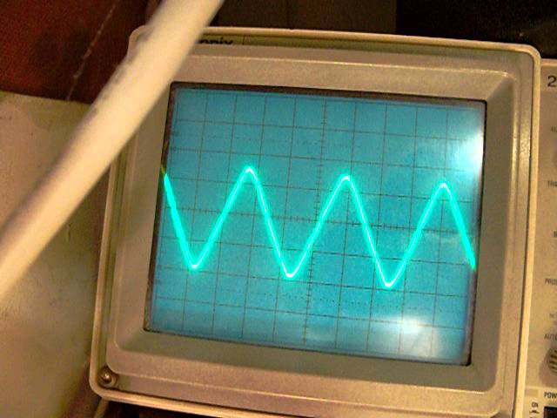

The overtones, or harmonics, are integral multiples of this fundamental frequency.

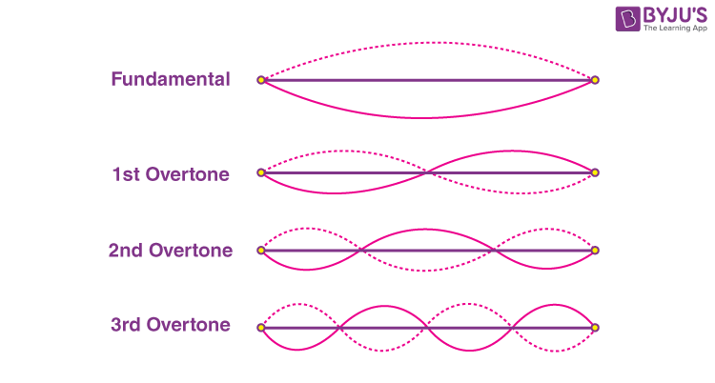

For instance, the first overtone (second harmonic) has a frequency twice the fundamental, the second overtone (third harmonic) has a frequency three times the fundamental, and so on.

The distribution of amplitudes among these harmonics determines the shape of the waveform.

In the case of a square wave, it can be decomposed into sine waves where even harmonics have zero amplitudes, and odd harmonics follow proportions like 1, 1/3, 1/5, and so forth.

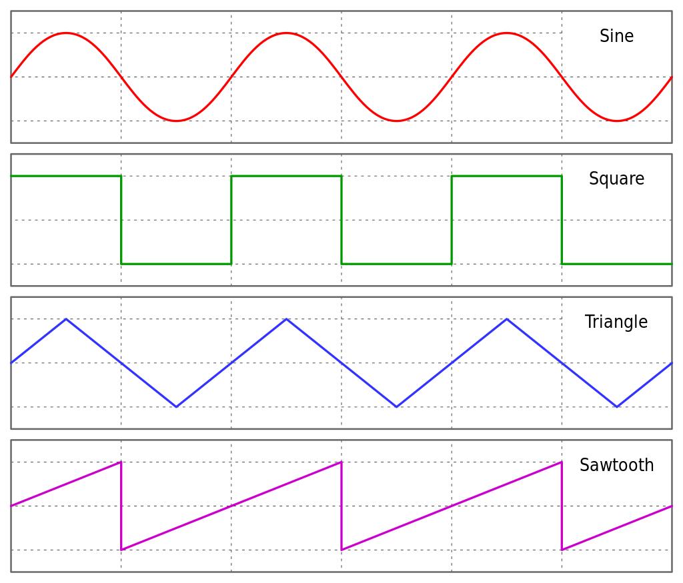

Conversely, a sawtooth wave includes all harmonics, with amplitudes following proportions like 1, 1/2, 1/3, 1/4, and so forth.

This additive synthesis approach reveals the underlying structure of complex waveforms, emphasizing the role of harmonics in shaping the tonal characteristics of different instruments.

The mathematical elegance of Fourier's findings provides a powerful tool for understanding and manipulating the rich tapestry of sound.

Experimenting with additive synthesis allows musicians and sound engineers to craft unique timbres and explore the intricate relationships between harmonics.

This exploration is not just a scientific endeavor but a creative one, offering avenues for innovation in music production and composition.

Hermann Helmholtz's Contribution and Evolution of Electronic Music Synthesis:

Hermann Helmholtz, a German scientist from the 19th century, played a pivotal role in shaping our understanding of timbre.

In his seminal work, "On the Sensations of Tone" (1885), Helmholtz proposed a theory suggesting that the ear and brain decompose complex tones into their constituent sine waves.

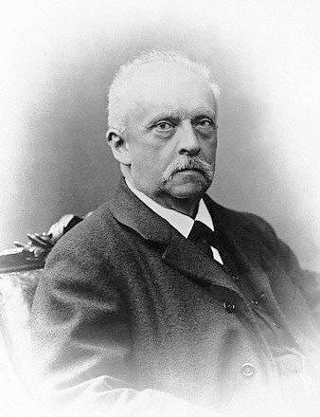

The perceived timbre is then derived from the relative intensities of these sine waves. However, the intricacies of timbre proved to be more nuanced than this initial proposition.

The landscape of electronic music synthesis underwent a transformative moment in 1968 with the release of Wendy Carlos's album "Switched on Bach."

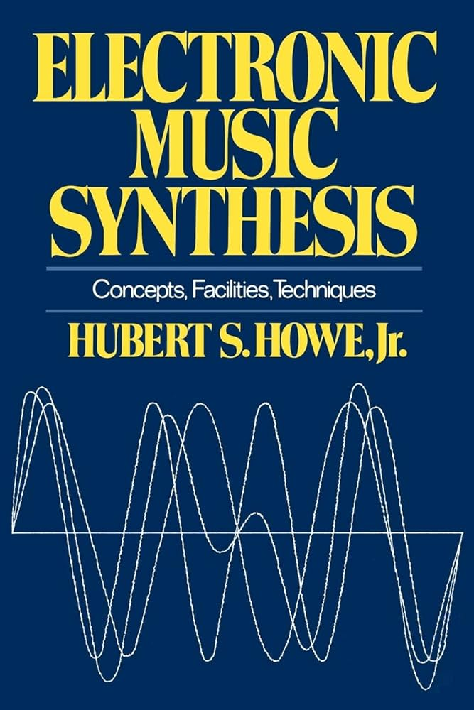

This marked the widespread introduction of analog synthesizers, such as the Moog, to the public. Analog synthesizers employ circuitry to generate diverse audio waveforms like square waves, triangle waves, and sawtooth waves.

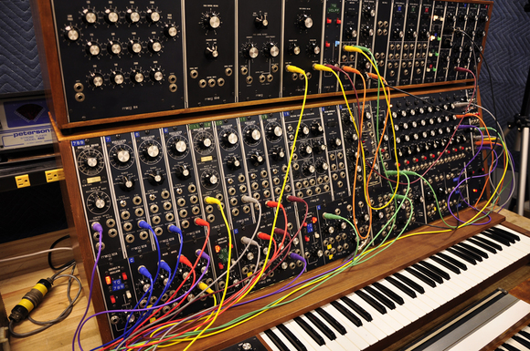

To emulate the characteristics of real musical instruments, these waveforms undergo modifications during a single note.

An essential aspect of shaping the sound in analog synthesizers is the use of an "envelope" to control the overall amplitude of the waveform.

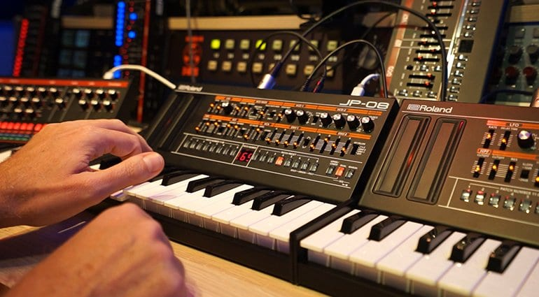

The envelope encompasses distinct phases: the attack, where the amplitude starts from zero and rises swiftly as the note begins; the sustain, where the amplitude remains constant during the note; and the release, where the amplitude falls to zero as the note concludes.

Filters are another integral element in analog synthesis. These filters attenuate certain harmonics, transforming simple waveforms into more complex and musically intriguing sounds.

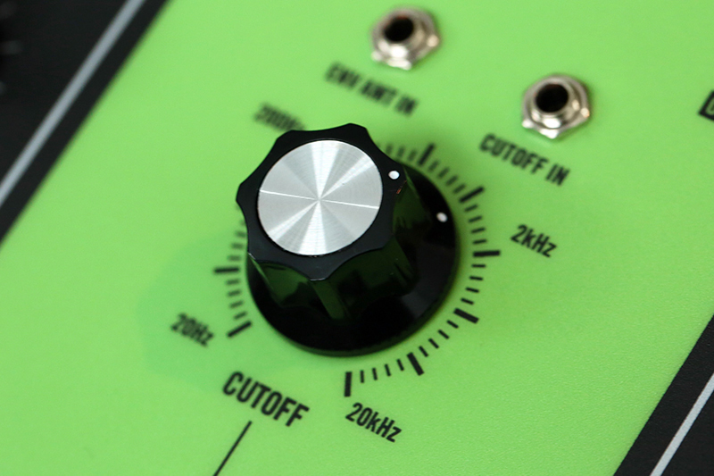

The cut-off frequencies of these filters can be dynamically adjusted by an envelope, influencing the harmonic content throughout the note duration. This approach, where harmonically rich waveforms are modified through filters, is known as "subtractive synthesis."

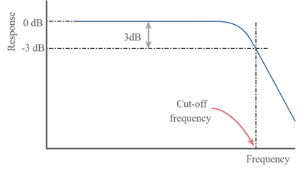

Despite the success of subtractive synthesis, the electronic music community saw potential in additive synthesis as the next frontier.

Additive synthesis involves starting with multiple sine wave generators tuned to integral multiples, with each sine wave representing a harmonic.

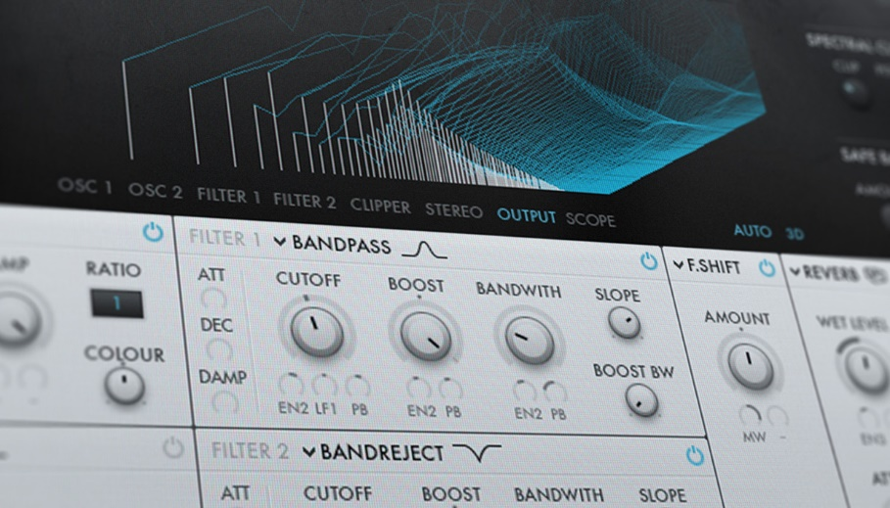

The amplitude of each harmonic can be independently controlled by an envelope.

However, implementing additive synthesis with analog circuitry presents challenges, as it would require a significant number of sine wave generators (between 8 and 24) for a single note, with precise tracking of their relative frequencies. Analog waveform generators are known for their instability and susceptibility to frequency drift.

Evolution of Additive Synthesis and the Complex Nature of Real Musical Tones:

The advent of digital synthesizers and computer-generated waveforms marked a significant milestone in the exploration of additive synthesis.

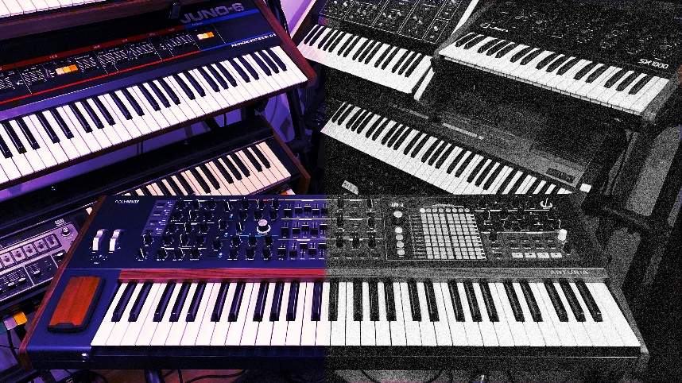

Unlike analog synthesizers with their susceptibility to frequency drift, digital synthesizers can generate waveforms digitally, enabling more precise control over harmonic components.

The fundamental concept involves recording a real musical tone, employing Fourier analysis to break it down into harmonics or partials, and digitally regenerating the sound using multiple sine waves.

However, as experimentation with Fourier analysis on real musical tones progressed, it became evident that the simplicity envisaged by Helmholtz did not fully capture the complexity of timbre.

Unlike ideal harmonic relationships, the partials of real musical tones are inharmonic, challenging the traditional notion of strict harmonicity. The term "partial" is more apt than "harmonic" for these components.

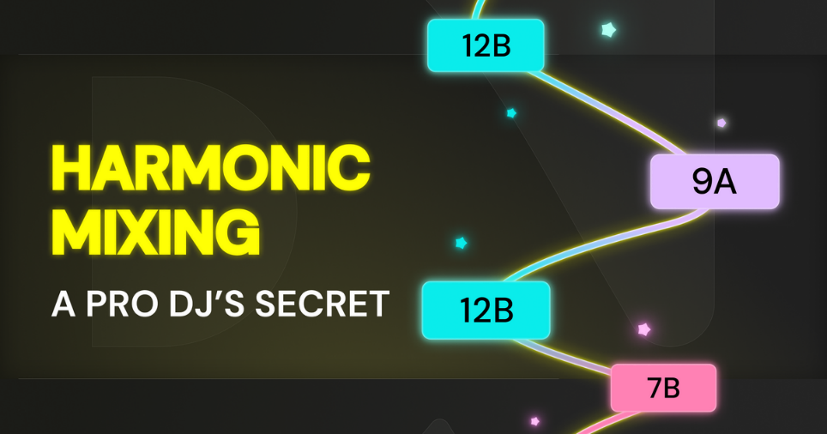

Inharmonicity plays a crucial role in making the tone sound authentic. Strict harmonicity tends to produce an "electronic" sound, while the inharmonic nature of real musical tones contributes to their richness and realism.

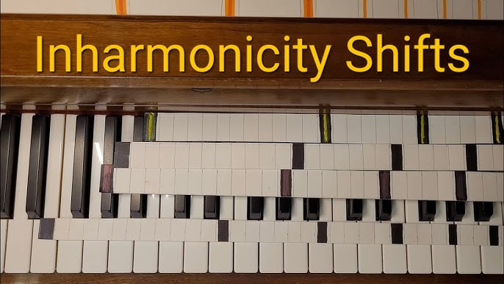

Each partial exhibits dynamic changes in both amplitude and frequency during a single note, with varying relationships among partials for different pitches and intensities from the same instrument.

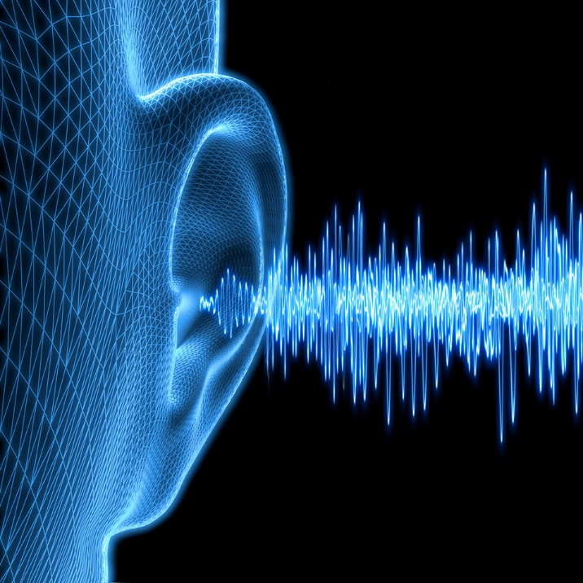

The most intricate part of a real musical tone occurs during the attack phase of the note, characterized by significant inharmonicity. This complex attack phase was identified as vital in human perception of timbre.

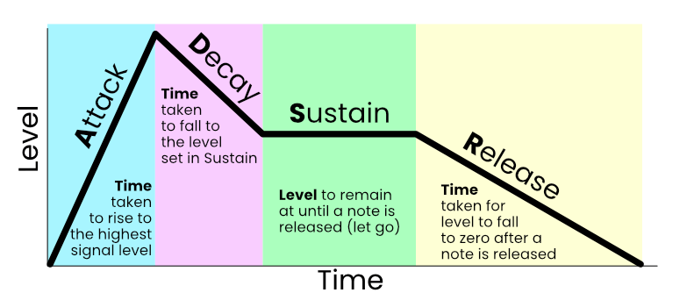

In summary, the sound of real musical instruments is far more intricate than initially envisioned. The idea of simplifying musical tones into a few basic envelopes for controlling partial amplitudes and frequencies proved impractical.

Early analyses published in the Computer Music Journal in the late 1970s, such as the "Lexicon of Analyzed Tones," provided numerical representations of amplitude and frequency graphs for partials of notes played on various instruments.

Partials are also known as components. The principal properties of the partials are their frequencies and amplitudes. The way the partials manifest in frequency, amplitude, and time is what our ears use to determine what kind of instrument made a particular sound.” With the support for waveforms in Windows, synthesizing these complex sounds became more feasible.

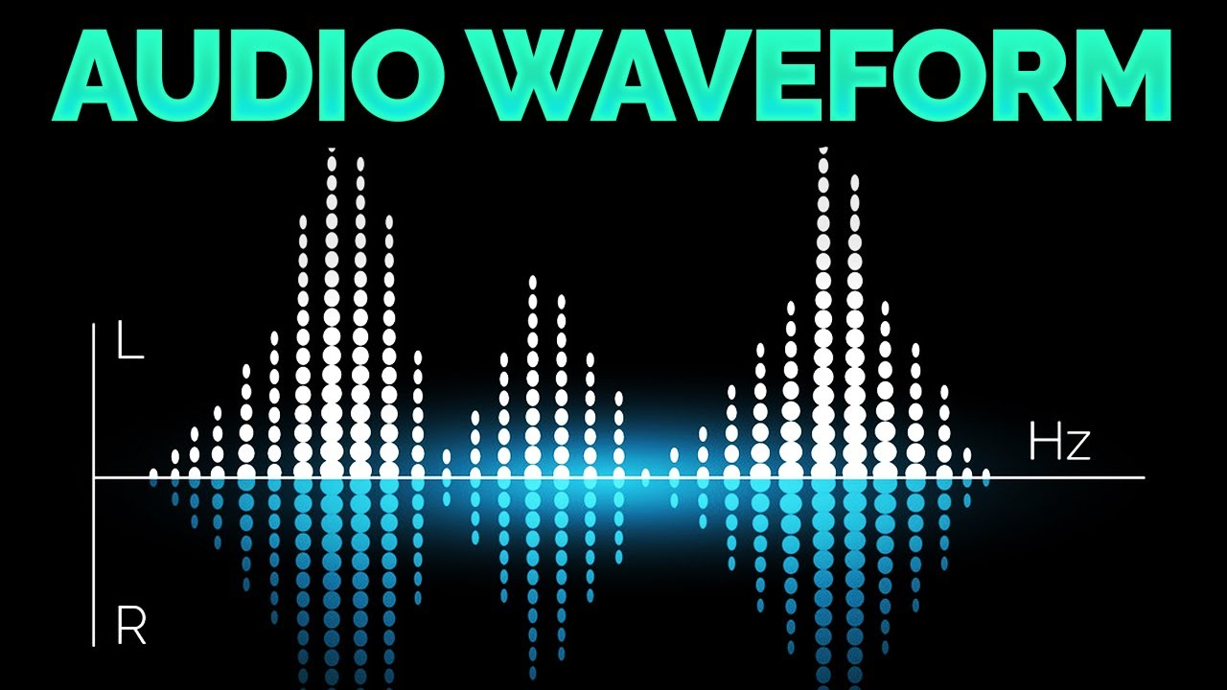

The ADDSYNTH ("additive synthesis") program, depicted in Figure 22-7, exemplifies this approach. By inputting numerical data representing frequency and amplitude envelopes for each partial, generating multiple sine wave samples, summing them up, and sending the samples to the waveform audio sound board, the program can reproduce sounds recorded over two decades ago.



This evolution in additive synthesis underscores the continuous exploration of sound synthesis techniques to capture the intricacies of real musical tones, offering new possibilities for creative expression in the realm of music production.

ADDSYNTH.C PROGRAM



Sine Wave Generation:

The SineGenerator function serves as the fundamental building block for the additive synthesis process. Its primary purpose is to generate a sine wave, the most basic form of a periodic waveform, based on a specified frequency. The frequency parameter determines the oscillation rate of the sine wave, corresponding to the pitch of the resulting sound.

Central to its operation is the concept of a phase angle. The function keeps track of this angle as it evolves over time. The phase angle is crucial for maintaining the continuity of the waveform, ensuring that successive samples are aligned in a seamless manner.

As the phase angle advances, the function calculates the sine values, producing a smooth and continuous oscillation. This capability is essential for creating harmonic components, which are the building blocks for more complex sounds.

Buffer Filling:

The FillBuffer function is responsible for the higher-level orchestration of additive synthesis. Its role extends beyond the generation of individual sine waves to the creation of a composite waveform. This composite waveform represents the culmination of multiple harmonic components, each contributing to the overall sound.

The function takes into account the amplitude and frequency envelopes for each harmonic. The amplitude envelope defines how the strength or volume of each harmonic evolves over time, while the frequency envelope governs how the pitch changes. By considering these envelopes, the function produces a dynamic and evolving sound characteristic.

As the function iterates through each harmonic, it calculates the contribution of each sine wave at a specific point in time, based on the current amplitude and frequency values. The individual contributions are then summed up to create the final composite waveform. This process mirrors the principles of additive synthesis, where complex sounds are synthesized by combining simpler sine wave components.

The resulting composite waveform is stored in a buffer, a temporary data structure that holds the audio samples. This buffer effectively captures the audio representation of the additive synthesis process, ready for further processing or playback.

Overall, the FillBuffer function encapsulates the essence of additive synthesis, allowing for the creation of diverse and expressive synthetic sounds.

Waveform File Creation:

The MakeWaveFile function is a pivotal component responsible for the creation of a waveform audio file in the WAV format. Leveraging the Windows API, this function manages essential file operations, ensuring the correct formatting of headers and the inclusion of waveform data. The resulting file is structured to adhere to the WAV format specifications, making it compatible with audio playback systems.

At its core, the function handles file creation using the CreateFile function from the Windows API. This function creates a new file or overwrites an existing one, providing a fresh canvas for the waveform audio data.

The subsequent steps involve calculating the sizes of various chunks within the WAV file, preparing the headers, and writing them to the file. The headers define critical information such as file type, audio format, sample rate, and bit depth.

Crucially, the function also fills the file with the actual waveform data, which has been previously generated through the additive synthesis process. The waveform data, stored in a buffer, represents the auditory output of the additive synthesis algorithm. By writing this data to the file, the function encapsulates the synthesized sound in a format compatible with audio playback systems.

User Interface (UI):

The program's user interface (UI) is designed as a straightforward Windows dialog-based interface, showcasing the utilization of the Windows API for graphical interaction. The UI serves as the interactive gateway for users to engage with the program's functionalities.

The main elements of the UI include individual buttons corresponding to different musical instruments, specifically the trumpet, oboe, and clarinet.

These buttons likely trigger the playback of the respective instrument's synthesized sound. Additionally, there is a text area within the UI dedicated to conveying the preparation status. This text area likely updates dynamically to inform the user about the current progress or status of the program.

The responsiveness of the UI to user interactions, such as button clicks, suggests an intuitive design aiming to provide a user-friendly experience.

The incorporation of buttons for each instrument indicates a modular approach, allowing users to selectively generate and play the synthesized sounds associated with different instruments.

In summary, the UI and its elements demonstrate the integration of the Windows API for creating a visually accessible and interactive platform. The UI serves as the control center through which users can initiate sound generation and playback processes, enhancing the overall usability of the program.

Instrument Specifics:

Within the program, each musical instrument—trumpet, oboe, and clarinet—is characterized by specific instrument structures (insTrum, insOboe, insClar). These structures likely encapsulate crucial parameters defining the unique sonic characteristics of each instrument.

Among these parameters, the amplitude and frequency envelopes play a pivotal role in shaping how the sound evolves over time. The envelopes are instrumental in providing a nuanced and realistic quality to the synthesized tones, mimicking the dynamic nature of real musical instruments.

The amplitude envelope is likely responsible for controlling the volume of the synthesized sound, determining how it swells, sustains, and fades. On the other hand, the frequency envelope governs the pitch modulation, contributing to the instrument's tonal variations. Together, these envelopes contribute to the authenticity and richness of the synthesized instrument sounds.

Testing and Playback:

The program incorporates a testing mechanism to validate the creation of sound files for each instrument. Upon successful creation, corresponding buttons on the user interface are enabled, reflecting the readiness of each instrument's sound for playback. The interactive nature of the UI allows users to engage with the program by pressing these buttons, initiating the synchronous playback of the generated sounds.

Playback functionality is likely facilitated by the PlaySound function, a Windows API function capable of playing sound files. The synchronous playback ensures that users can instantly experience the results of the additive synthesis process for each instrument.

Timer and Cursor Handling:

To manage asynchronous operations, the program employs a timer with the identifier ID_TIMER. Timers in Windows applications are often used to schedule periodic tasks or delays. In this context, the timer likely contributes to the orchestration of background tasks, ensuring smooth execution of operations without blocking the main user interface.

Cursor handling is another aspect managed by the program. The cursor, a graphical indicator of the user's interaction with the program, is dynamically managed to provide visual feedback during specific processing states. For instance, the cursor may change to indicate a wait state (IDC_WAIT) during resource-intensive tasks, offering a visual cue to the user about ongoing background processes.

Resource Files:

The ADDSYNTH.RC file serves as a repository for resource definitions related to the dialog-based user interface. It includes specifications for buttons, their associated IDs, positions, and captions. This file plays a vital role in defining the visual layout and behavior of the UI elements.

The RESOURCE.H file complements the resource definitions by providing symbolic constants for various UI controls. These constants enhance code readability and maintainability by associating meaningful names with control IDs, reducing reliance on numerical values.

*Let’s explain some structures in the program a bit more…*

Structures in ADDSYNTH.H:

ADDSYNTH.H defines three crucial structures: ENV, PRT, and INS. ENV represents amplitude and frequency envelope data, using number pairs for time and value. PRT stores the number of points and a pointer to the ENV array, acting as a container for partials. INS encapsulates the total tone time, partial count, and a pointer to the PRT array. These structures collectively manage envelope data, partial definitions, and instrument characteristics within the program.

Envelopes and Partial Definitions:

The ENV structure in ADDSYNTH.H holds time-value pairs representing amplitude or frequency. Straight-line connections link these pairs, defining the envelope's shape. Array lengths vary (6 to 14 values), determining the envelope's complexity. PRT, storing the number of points and a pointer to ENV, manages partial definitions. These structures collectively define how amplitude and frequency evolve over time, shaping the instrument's sound.

Calculation of Total Composite Maximum Amplitude:

The FillBuffer function calculates the total composite maximum amplitude by iterating through partials. It finds the maximum amplitude for each partial and aggregates them. This composite maximum amplitude is crucial for scaling samples to an 8-bit size, ensuring proper representation. Its significance lies in determining the overall volume and intensity of the synthesized sound, impacting the quality of the final output.

Sine Wave Generation and Phase Angle:

The SineGenerator function generates sine waves based on a given frequency, maintaining a phase angle for continuous waveform creation. It plays a pivotal role in additive synthesis by producing individual harmonic components. The phase angle's management is crucial for creating a coherent and seamless waveform. Understanding the digital sine wave generation process provides insights into how harmonics are generated and contribute to the overall sound.

Real-Time Calculations and Button Enablement:

ADDSYNTH acknowledges the computational demands of additive synthesis, indicating that real-time calculations may be impractical on current PCs. The program dynamically enables push buttons after completing initial calculations. A deeper exploration of the computational strategy would shed light on how the program optimizes additive synthesis calculations. Understanding the button-enablement mechanism adds insight into when users can interact with the UI based on the program's state.

Persistent Waveform File Checking:

The program checks for the existence of waveform files during subsequent runs to optimize efficiency. This file-checking mechanism ensures that, if waveform files already exist, the program skips unnecessary recalculations. A more detailed explanation of this mechanism would clarify how the program manages previously generated sound files, enhancing the user experience and program efficiency in subsequent executions.

WAKEUP ALARM CLOCK PROGRAM





Includes and Definitions:

The inclusion of necessary header files, such as windows.h and commctrl.h, provides essential functionality for the Windows operating system and common controls.

The program defines specific ID values for child windows, a timer ID, and constants associated with waveform generation. These definitions contribute to the overall structure and functionality of the program by providing unique identifiers and constants for various components.

Waveform Structure:

The WAVEFORM structure is a crucial component in the program, representing a simulated waveform "file." It consists of several fields that define the structure of the audio data. Let's delve deeper into each field:

* chRiff[4]: This array represents the RIFF identifier, indicating the file format. The "RIFF" identifier signifies a Resource Interchange File Format.
* dwRiffSize: This DWORD specifies the size of the RIFF chunk, indicating the total size of the file minus 8 bytes.
* chWave[4]: The "WAVE" identifier denotes the file as a waveform audio file within the RIFF structure.
* chFmt[4]: This field holds the "fmt " identifier, indicating the beginning of the format chunk.
* dwFmtSize: A DWORD representing the size of the format chunk, excluding the first 8 bytes.
* pwf: The PCMWAVEFORMAT structure contains information about the waveform format, including sample rate, number of channels, and bits per sample.
* chData[4]: This array holds the "data" identifier, marking the beginning of the data chunk.
* dwDataSize: A DWORD specifying the size of the data chunk, indicating the length of the waveform data.
* byData[0]: This flexible array member represents the actual waveform data. It is an array of structures containing amplitude values for each sample.

Understanding the structure of the WAVEFORM allows for a detailed comprehension of how the program organizes and represents audio data within its internal workings. Each field plays a specific role in defining the format and content of the simulated waveform file.

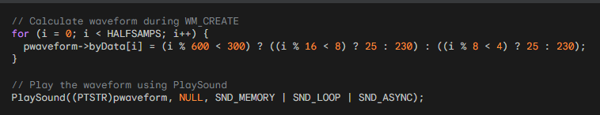

Window Procedure and Subclassing:

The main window procedure, WndProc, serves as the central hub for handling messages related to the program's functionality.

Messages such as WM_CREATE, WM_COMMAND, WM_NOTIFY, and WM_DESTROY are processed within this procedure.

An essential aspect of the program's design is the subclassing of three child windows: the date and time picker, the checkbox, and the push button.

Subclassing is achieved by assigning new window procedure addresses (SubProc) to these controls. This enables custom handling of messages for each specific control, allowing for tailored behavior.

Initialization and Child Windows:

In the WM_CREATE message, the program undergoes necessary initialization procedures.

It registers window class information, creates the main window, and performs common control initialization using InitCommonControlsEx.

Additionally, the program creates a waveform file with alternating square waves. Three child windows are set up: a date and time picker (hwndDTP), a checkbox (hwndCheck) for setting the alarm, and a push button (hwndPush) for turning off the alarm.

The date and time picker is initialized with the current time plus 9 hours, providing a default alarm time.

User Interaction Handling:

The WM_COMMAND message is crucial for handling various user interactions within the program. Specific actions are taken in response to control events.

When the user checks the "Set Alarm" checkbox, the program calculates the time difference between the selected time in the date and time picker and the current PC time.

A one-shot timer is set, and the alarm sound is played when the timer elapses. Unchecking the checkbox cancels the timer.

Clicking the "Turn Off" button stops the alarm sound, resets the interface by unchecking the checkbox, and enables user interaction with the date and time picker. This mechanism provides a user-friendly interface for setting and turning off alarms.

Date and Time Picker Handling:

The program utilizes the WM_NOTIFY message to manage notifications from the date and time picker control (hwndDTP).

Specifically, when the user changes the alarm time while the alarm is set (checked), the program takes action. It unchecks the "Set Alarm" button, indicating a change in the alarm setting, and ensures that any outstanding timer is terminated.

This mechanism prevents discrepancies between the displayed time and the one-shot timer when the user adjusts the alarm time.

Timer Handling:

The WM_TIMER message is responsible for handling the one-shot timer set by the program when the user checks the "Set Alarm" button.

Upon receiving the timer message, the program takes several actions. It first kills the timer, ensuring that the alarm sound is a one-time occurrence.

Subsequently, it initiates the annoying alarm sound by playing the waveform data. Simultaneously, UI elements are manipulated to reflect the transition from the alarm-triggered state to a responsive interface.

The date and time picker and checkbox are re-enabled, while the push button gains focus, preparing the program for user interaction.

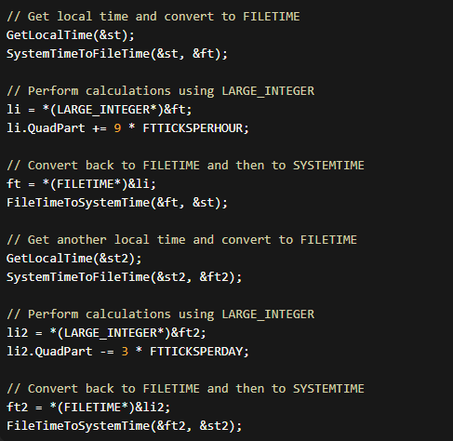

FILETIME Structure and Large Integer Operations:

The FILETIME structure, consisting of dwLowDateTime and dwHighDateTime, represents a 64-bit value indicating intervals from January 1, 1601.

The Microsoft C/C++ compiler introduces the __int64 type, allowing arithmetic operations on 64-bit integers. The union LARGE_INTEGER provides a flexible way to handle the large integer as two 32-bit quantities or a single 64-bit quantity. This methodology aligns with the Windows Base Services documentation on Large Integer Operations.

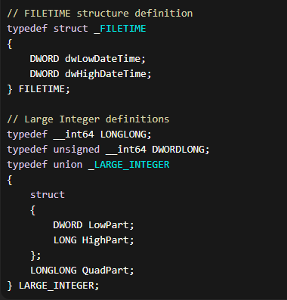

Cleanup and Window Destruction:

The WM_DESTROY message serves as the endpoint for the program's execution. This section ensures proper cleanup and resource management before the program exits.

It frees the memory allocated for the waveform data, stopping the alarm sound if it is still playing. Additionally, it checks if the "Set Alarm" checkbox is checked and, if so, kills any remaining timer to prevent unexpected alarm triggers. This meticulous cleanup guarantees the program concludes gracefully, leaving no residual effects.

DEEP DIVE INTO MIDI AND MUSIC: BEYOND THE BASICS

This passage provides a solid overview of MIDI (Musical Instrument Digital Interface), but let's delve deeper into its intricacies and explore its impact on the world of music.

Beyond Note On and Note Off:

While the explanation of basic Note On/Off messages is accurate, MIDI's capabilities extend far beyond. It transmits various types of data, including:

* Pitch Bend: Fine-tuning the pitch of a note for expressive playing.
* Aftertouch: Applying pressure to a key after striking it for dynamic control.
* Control Change: Modifying sound parameters like vibrato, filter cutoff, or volume.
* Program Change: Selecting different sounds on the synthesizer.
* Sysex (System Exclusive): Sending manufacturer-specific commands for advanced functionality.

These messages enable advanced musical expression, allowing MIDI controllers to mimic the nuances of acoustic instruments and create unique sonic textures.

The Rise of Sequencers and Computer Integration:

While stand-alone sequencers have diminished in popularity, their role in shaping music cannot be overstated.

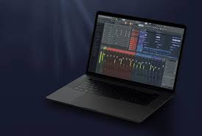

They offered early musicians the ability to record and edit sequences, paving the way for complex arrangements and groundbreaking electronic genres. The integration of MIDI with computers further revolutionized music production.

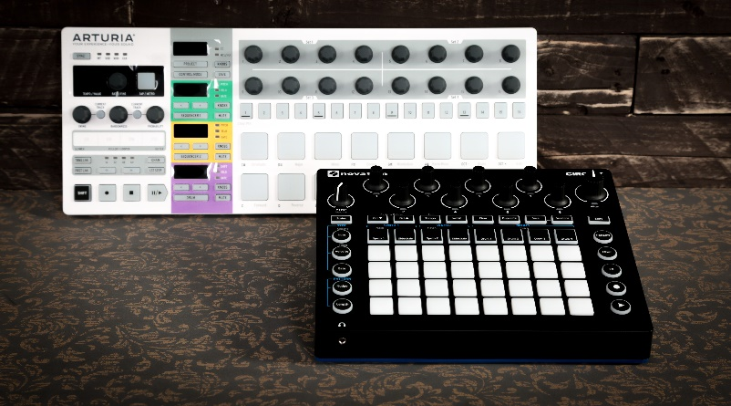

Software sequencers like Pro Tools and FL Studio became essential tools for composing, editing, and mixing music, providing unparalleled flexibility and accessibility.

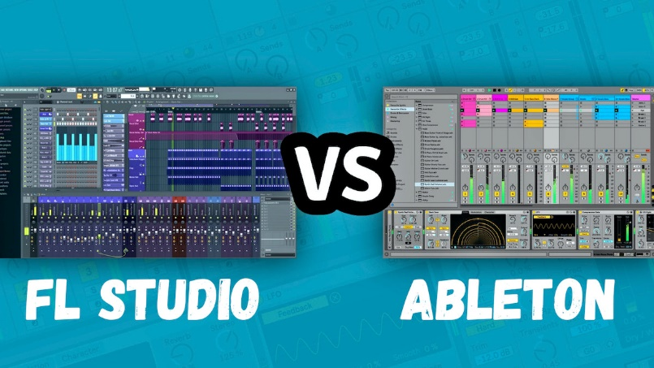

Beyond Controllers and Synthesizers:

The MIDI ecosystem extends beyond keyboards and synthesizers. Drums, guitars, wind instruments, and even vocals can be equipped with MIDI capabilities, allowing seamless integration into digital setups.

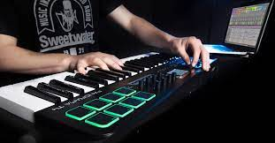

Moreover, MIDI interfaces connect controllers and instruments to computers, opening up a world of virtual instruments and sound libraries.

The Impact of MIDI:

MIDI's influence on music is undeniable. It:

Democratized music creation: Made producing music more accessible and affordable, fostering a vibrant amateur and independent music scene.



Birthed new genres: Electronic music as we know it wouldn't exist without MIDI, giving rise to techno, house, and countless other styles.

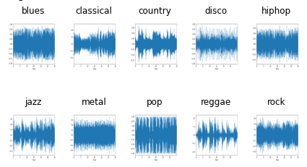

Revolutionized live performance: Musicians can control multiple instruments and complex soundscapes with a single MIDI controller, enhancing stage shows.



Preserved musical heritage: MIDI files act as digital sheet music, ensuring the longevity of compositions and facilitating collaboration.



Looking Ahead:

MIDI continues to evolve with new specifications and capabilities. Wireless MIDI connections simplify setups, and integration with artificial intelligence opens up exciting possibilities for interactive music creation. As technology advances, MIDI's role in shaping the future of music remains significant.

This deep dive paints a more comprehensive picture of MIDI, showcasing its power and versatility. It goes beyond the technical details to highlight its cultural impact and lasting legacy in the world of music.

SWITCHING SOUNDS WITH PROGRAM CHANGES: NAVIGATING THE SONIC LANDSCAPE OF SYNTHESIZERS

Understanding Program Changes:

Accessing Diverse Sounds: Synthesizers store a vast array of sounds, often called voices, instruments, or patches. To switch between these sounds, MIDI uses Program Change messages.

Sending the Message: The message is simple: C0 pp, where pp ranges from 0 to 127, selecting a specific program.

Common Controls: MIDI keyboards often feature numbered buttons to directly send these messages, allowing convenient sound selection.

The Program Number Challenge:

Lack of Standardization: MIDI itself doesn't dictate which program numbers correspond to specific instruments. This means the same program number on different synthesizers might trigger vastly different sounds.

Unexpected Surprises: Without knowing the synthesizer's sound mapping, Program Change messages can lead to unexpected results.

MIDI File Compatibility Issues: MIDI files containing Program Change messages might sound different on different devices, posing a challenge for portability.

Enter General MIDI (GM):

Standardization Effort: To address this issue, General MIDI (GM) was introduced to standardize program numbers across compliant devices.

Widespread Adoption: GM is widely supported by software and hardware, promoting consistency and predictability.

Ensuring Compatibility: When working with MIDI files, using GM-compliant sounds or mapping non-compliant synthesizers to GM standards ensures the intended sound playback.

Key Takeaways:

* Program Change messages are essential for exploring a synthesizer's sonic palette.
* Understanding program number variations is crucial for avoiding surprises and ensuring compatibility.
* General MIDI offers a standardized framework for predictable sound selection across devices.
* When working with MIDI files, consider GM compatibility for consistent playback.

UNVEILING THE ORCHESTRA WITHIN: A DEEP DIVE INTO MIDI CHANNELS

Imagine a single cable carrying the symphony of 16 distinct instruments—that's the magic of MIDI channels.

Orchestrating Communication:

Separate Channels, Unified Cable: This note highlights how MIDI channels allow for independent communication pathways within a single MIDI cable. Each channel can carry its own set of MIDI messages, enabling multiple devices to interact seamlessly. This organization ensures that different devices can communicate without interference or confusion.

Assigning Roles, Avoiding Collisions: Each MIDI device is assigned a unique channel to ensure that it responds only to messages intended for it. This assignment helps prevent sonic chaos by avoiding collisions between devices. By designating specific channels for each device, MIDI ensures that messages are received and interpreted correctly.

The Status Byte: A Cunning Conductor: The status byte, which is the first byte of each MIDI message, plays a crucial role in MIDI communication. It holds the channel information within its lower four bits, indicating the intended recipient of the message. The status byte acts as a conductor, directing the message to the correct device by specifying the appropriate channel.

16 Instruments, One Cable: MIDI cables have the capability to convey messages for up to 16 instruments simultaneously. Each instrument is assigned to a distinct channel, allowing for the transmission of messages related to different sounds or instruments over a single cable. This feature enables the creation of intricate and rich sonic tapestries by combining multiple MIDI devices.

Deconstructing MIDI Messages:

Note On: The Note On message is used to trigger the start of a musical note. It consists of three components:

* Status Byte: The Status Byte for the Note On message is represented by 9n, where "n" designates the MIDI channel (from 0 to 15). The channel allows multiple MIDI devices to communicate independently.
* Key Number: The Key Number, represented by "kk," specifies the pitch of the note being played. It corresponds to a specific musical pitch or key on a keyboard or other MIDI controller. The key number ranges from 0 to 127, with 60 typically representing middle C.
* Velocity: The Velocity byte, represented by "vv," determines the intensity or strength with which the note is played. It represents the force or speed at which a key is struck on a MIDI controller. The velocity value ranges from 0 to 127, with 0 representing the release of a note and 127 representing the maximum intensity.

Program Change: The Program Change message allows for selecting different sounds or patches on a MIDI device. It consists of two components:

* Status Byte: The Status Byte for the Program Change message is represented by Cn, where "n" identifies the MIDI channel (0 to 15) on which the change is applied.
* Program Number: The Program Number, represented by "pp," specifies the desired sound or patch to be selected. Each number corresponds to a different sound or instrument on the MIDI device's internal sound bank. For example, program number 0 might correspond to a piano sound, while program number 32 could represent a guitar sound.

Channel Multiplexing:

* MIDI allows for simultaneous conversations or communication between multiple MIDI devices or channels.
* This is achieved through the use of different MIDI channels, each capable of carrying its own set of MIDI messages.
* Each MIDI channel is independent and can transmit its own Note On, Note Off, Control Change, and other MIDI messages.
* This channel multiplexing capability allows for the simultaneous control and playback of multiple sounds or instruments.
* For example, one channel can be used for a piano sound, another for a bass guitar, and so on, allowing for complex and layered musical arrangements.

Overall, MIDI messages provide a standardized way of communicating musical information, such as note events, sound selection, and control parameters, between MIDI devices. By deconstructing and understanding these messages, musicians and producers can manipulate and shape the sounds produced by MIDI devices to create expressive and diverse musical compositions.

The conversation flow in MIDI begins with initial Program Change messages, which serve as the foundation for each channel. These messages assign a specific voice or instrument to each channel, similar to assigning instruments to musicians in an orchestra. This step establishes the sonic palette and sets the stage for the harmonious interplay that follows.

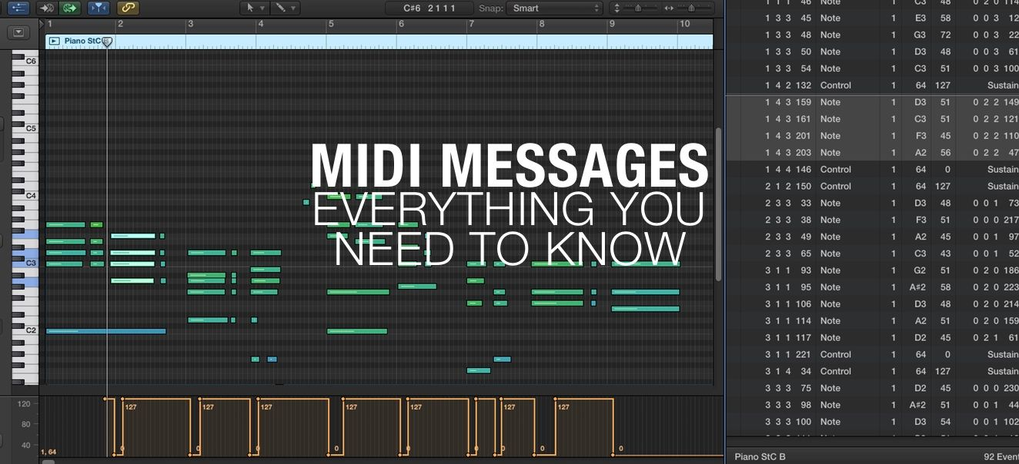

Once the Program Change messages have set the voices, a flurry of Note On and Note Off commands ensues. These commands trigger the start and end of individual notes on their designated channels. As different notes are played on various channels, a rich and harmonious interplay emerges, as if each voice in the composition is speaking its part in a musical conversation.

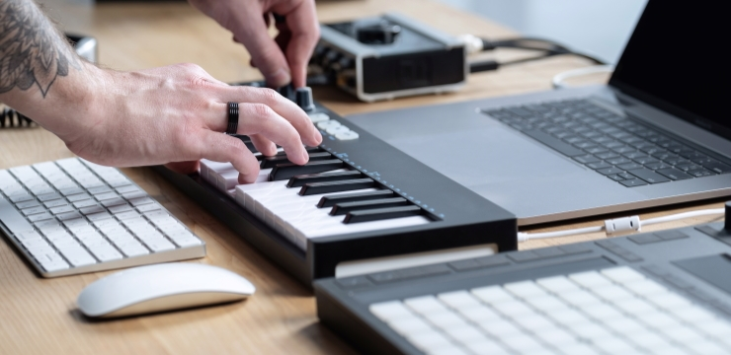

In addition to the initial voice assignments, MIDI allows for additional Program Change messages to be sent during a performance. These messages can dynamically switch sounds or instruments mid-performance, adding versatility and creating dynamic shifts in the music. This flexibility allows musicians to explore different sonic landscapes and adapt the composition in real-time, adding depth and variety to their performances.

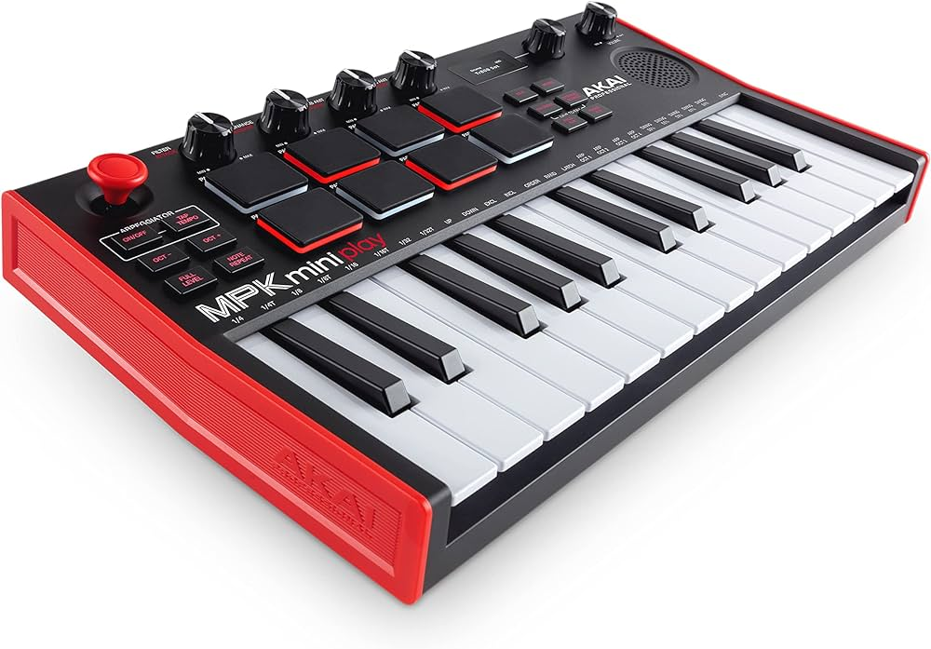

To ensure clarity and prevent cacophony, MIDI dedicates each channel to a single voice at any given moment. This means that each channel carries the musical information for a specific instrument or sound. By dedicating channels to individual voices, MIDI achieves a clear and organized musical expression, where each voice can be heard distinctly within the overall composition.

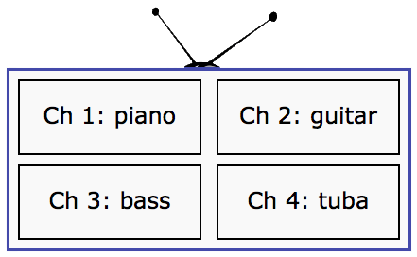

MIDI channels play a crucial role in harnessing the power of MIDI technology. They empower musicians to create intricate arrangements using multiple instruments, all controlled through a single cable.

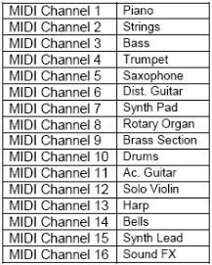

By assigning different voices to separate channels, musicians can layer sounds, blend different instruments, and create complex musical compositions.

Understanding the assignment of channels and the structure of MIDI messages is essential for effective MIDI control, as it enables seamless interaction between MIDI devices and facilitates the realization of musical ideas.

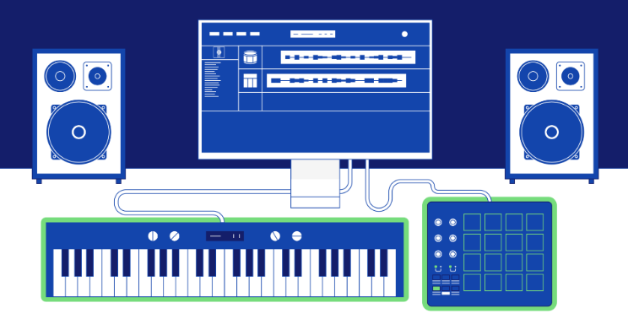

Proper channel configuration forms the foundation of a symphony in MIDI. By setting up channels correctly, musicians can unlock the full potential of MIDI technology and create layered, expressive, and immersive musical compositions.

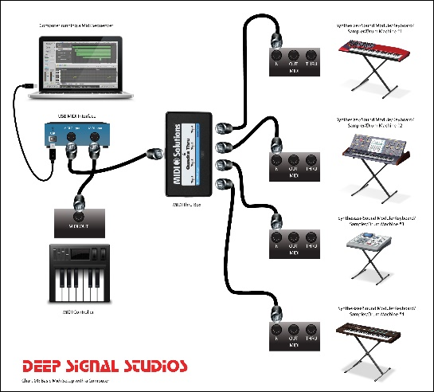

MIDI channels embody the essence of MIDI's versatility, allowing a simple cable to unleash a symphony of sounds. By mastering the mechanics of MIDI channels, musicians tap into a realm of limitless possibilities, where multiple voices blend and flow in perfect harmony, bringing their musical visions to life.

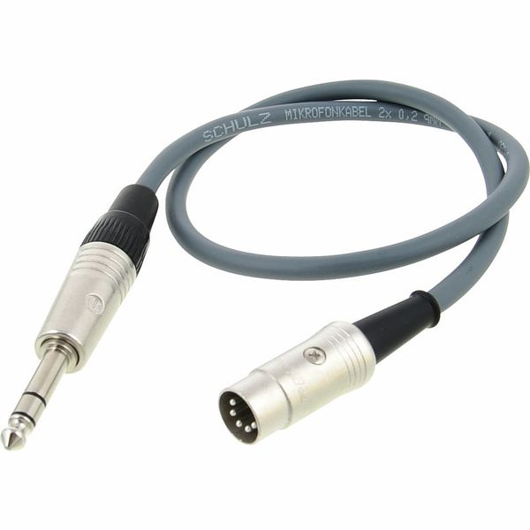

Assignment of channels and the structure of MIDI messages

MIDI channels are independent communication pathways within a MIDI system. Each channel is assigned a unique number from 0 to 15, allowing multiple devices to communicate simultaneously without interference. Assigning different voices or instruments to separate channels enables musicians to create intricate arrangements and layered compositions. It ensures that each voice has its dedicated channel, promoting clarity and preventing sonic chaos.

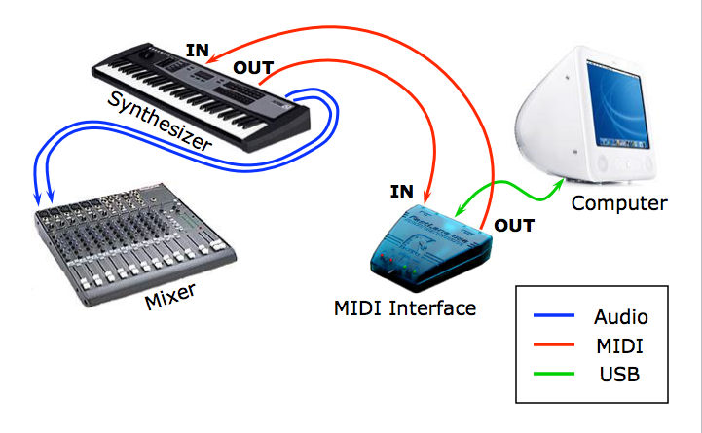

The structure of MIDI messages consists of various components. The status byte, which is the first byte of each MIDI message, carries information about the type of message and the intended recipient channel. It plays a vital role in directing the message to the correct device by specifying the appropriate channel. The following data bytes convey specific information related to the message type, such as pitch, velocity, program number, or control parameters.

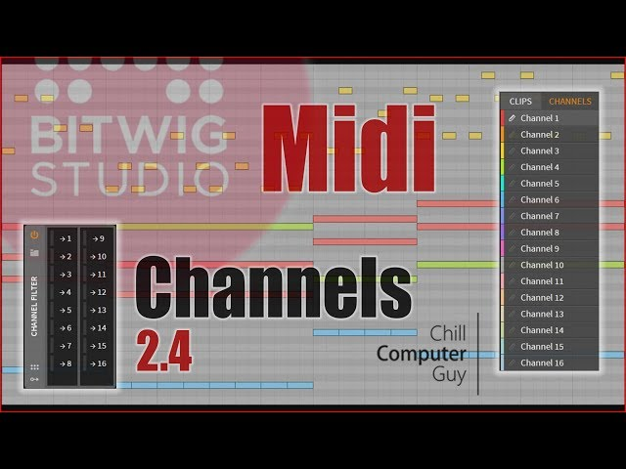

Understanding the structure of MIDI messages and the assignment of channels is crucial for effective MIDI control. It allows musicians to send and receive the right messages to control sounds, trigger notes, switch instruments, and modulate various parameters. With this understanding, seamless interaction between MIDI devices can be achieved, enabling musicians to create expressive performances and unlock the full potential of MIDI technology.

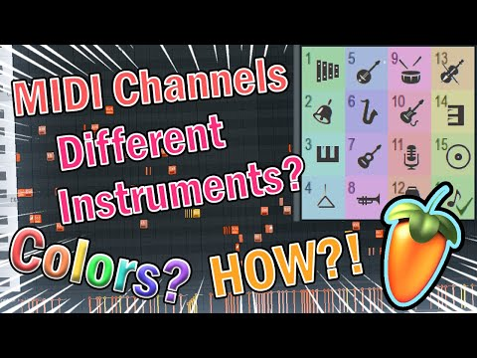

UNLEASHING THE MULTI-INSTRUMENTAL POWER OF MIDI CHANNELS: A DEEP DIVE

Transforming a Single Keyboard into a Duet:

Sending Program Change Messages:

* C0 01 sets channel 1 to program 2 (remember, 0-based encoding).
* C1 05 sets channel 2 to program 6.

Playing in Unison: Each key press triggers two Note On messages, one for each channel, playing both instruments simultaneously.

Splitting the Keyboard for Independent Control:

* Lower Keys, Channel 1: Notes played on the lower keys control channel 1, activating its assigned instrument.
* Upper Keys, Channel 2: Notes played on the upper keys control channel 2, playing its distinct sound.
* Result: A single keyboard becomes a versatile tool capable of performing two independent parts.

Splitting the keyboard for independent control is a technique that allows a single keyboard to perform two separate parts or voices by assigning different MIDI channels to specific sections of the keyboard.

In this technique, the lower keys of the keyboard are assigned to control channel 1, while the upper keys are assigned to control channel 2. Each channel is associated with its own instrument or sound.

When a musician plays notes on the lower keys, MIDI messages are sent on channel 1, activating the instrument assigned to that channel. This means that the lower notes trigger sounds or play notes associated with channel 1, creating a specific musical voice or part.

On the other hand, when the musician plays notes on the upper keys, MIDI messages are sent on channel 2, controlling the instrument or sound assigned to that channel. The upper notes produce a distinct sound or play a different musical part associated with channel 2.

By splitting the keyboard and assigning different channels to each section, the musician gains independent control over two voices or parts. They can play different melodies, harmonies, or rhythms with each hand, effectively transforming a single keyboard into a versatile tool capable of performing as if two separate instruments were playing simultaneously.

This technique is commonly used in live performances, studio recordings, and musical arrangements where a single musician wants to create a fuller and more dynamic sound. It allows for greater expressiveness and flexibility in playing and composing music, as the musician can explore different musical ideas and textures by controlling multiple voices independently.

Orchestrating a 16-Piece Band from a PC:

Orchestrating a 16-piece band from a PC involves utilizing MIDI sequencing software as the conductor, which assigns each instrument to a unique MIDI channel. This software serves as a virtual maestro, directing and coordinating the various instruments in the ensemble.

In this scenario, each MIDI channel is assigned to control a specific instrument or sound. For example, channel 1 might be assigned to a flute, channel 2 to a violin, channel 3 to a bass, and so on. By assigning each instrument to a distinct channel, a diverse range of sounds and timbres can be created, allowing for a rich and realistic ensemble experience.

What makes this orchestration even more remarkable is that it can be achieved using just a single MIDI cable. All the instrument data, including note information, dynamics, and other musical parameters, is transmitted through this single cable to a MIDI-compatible synthesizer or sound module.

The MIDI sequencing software running on the PC generates and sends the MIDI messages for each instrument on their respective channels. These messages are then received by the synthesizer, which interprets them and produces the corresponding sounds based on the assigned instrument or sound for each channel. This allows the PC to effectively control and coordinate the entire 16-piece band, creating a seamless and cohesive musical performance.

By leveraging the power of MIDI and MIDI sequencing software, musicians and composers can orchestrate complex musical arrangements and compositions directly from their PC. This approach offers a level of convenience and flexibility, as it eliminates the need for physical instruments and allows for easy editing, arranging, and recording of MIDI data. It also provides a cost-effective solution, as a single MIDI cable can transmit the performance data for the entire ensemble.

Key Takeaways:

MIDI Channels = Independent Instrument Pathways: MIDI channels serve as separate communication pathways within the MIDI system, enabling multiple instruments to coexist and communicate over a single cable.

Channel Assignment = Essential for Control: Assigning instruments or sounds to specific MIDI channels ensures that MIDI messages are directed precisely to their intended targets. This prevents sonic collisions and allows for individual control over each instrument.

Keyboard Versatility: MIDI channels offer keyboards the versatility to play multiple instruments independently. Through channel assignments, keyboards can trigger different sounds or play separate musical parts, either in unison or through split configurations, expanding the expressive possibilities of a single keyboard.

Sequencing Software = Virtual Orchestra: MIDI sequencing software acts as a virtual conductor, making use of MIDI channels to create complex arrangements for multi-instrument compositions. By assigning different instruments to specific channels, the software can orchestrate and control the entire ensemble, allowing for sophisticated musical productions and performances.

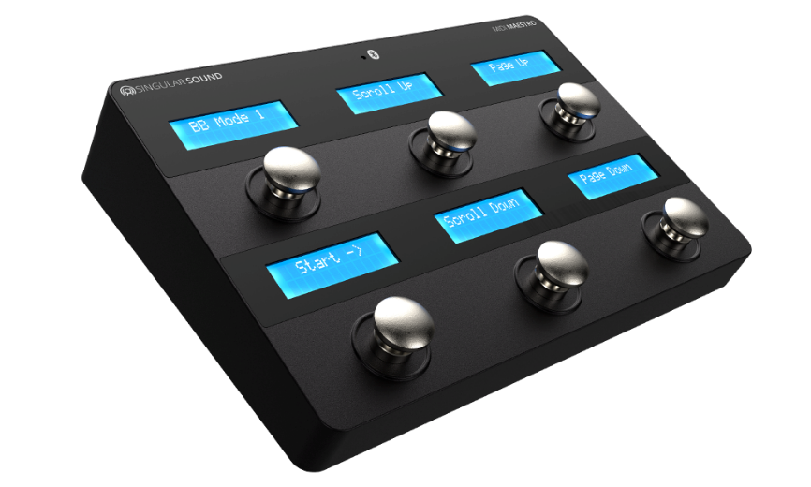

MIDI Messages:

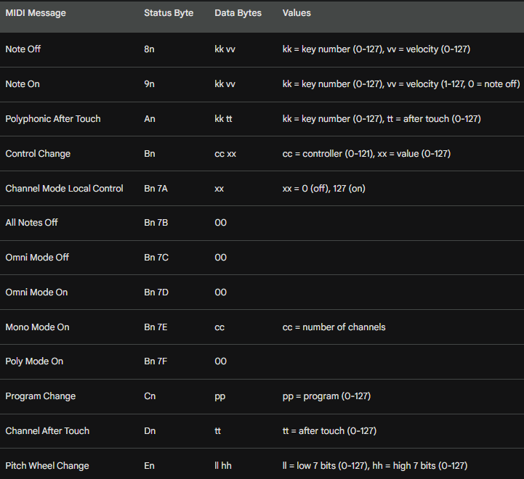

Decoding the MIDI Orchestra: A Grand Tour of Messages Beyond the Basics

Remember the symphony behind MIDI? Its language, beyond the basic melodies of Note On and Program Change, holds rich layers of expression and control.

Let's dive deeper into these messages, appreciating their nuanced roles in the musical performance.

Key Numbers: Beyond the Western Scale:

While key numbers often map to the familiar Western Music scale, their versatility shines through. Percussion instruments, for instance, assign each key to a unique sound, transforming the keyboard into a drum machine. Moreover, MIDI extends the range beyond a piano's grasp, venturing 21 notes down and 19 notes up, opening doors for sonic exploration unseen on an 88-key instrument.



Velocity: Sculpting the Sound:

The velocity, captured in a simple number, isn't just about volume. It's a sculptor's chisel, shaping the character of the sound. On piano-like voices, it influences both loudness and the harmonic richness, from a delicate murmur to a thunderous roar. But remember, different voices may react in unique ways, adding another layer of expressive potential.

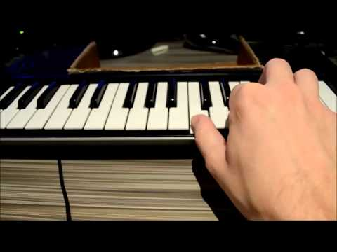

Aftertouch: A Dynamic Embrace:

Some keyboards offer the magic of aftertouch, allowing you to dynamically alter the sound by applying pressure to a pressed key. It's like whispering secrets to the notes, subtly changing their character. Two types of aftertouch messages exist: one influencing all playing notes in a channel, and the other, a more intimate conversation, affecting each key independently.

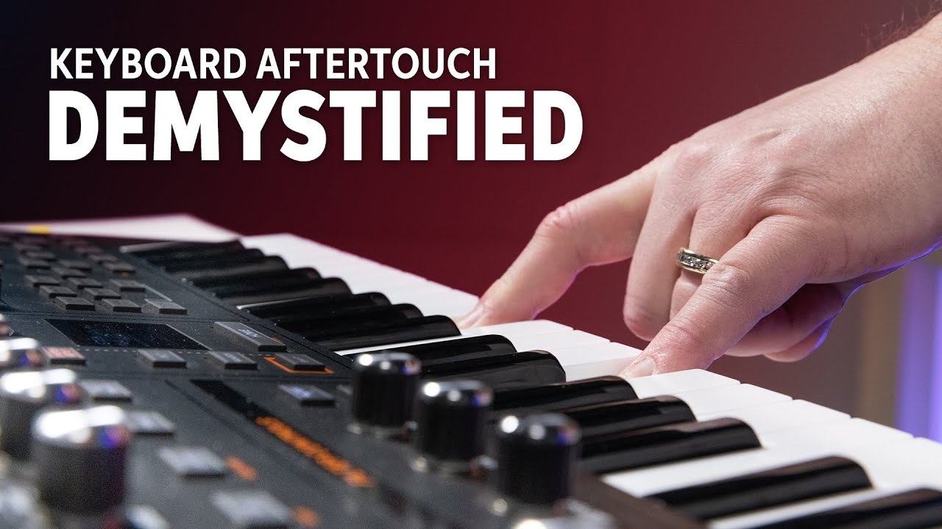

Controllers: Fine-Tuning the Canvas:

Knobs and switches on your keyboard aren't mere ornaments; they're gateways to sonic nuance. These controllers send out Control Change messages, identified by unique numbers. This allows you to tweak parameters like reverb, filter cutoff, or vibrato intensity, painting your sonic canvas with exquisite detail. Additionally, the same message type acts as a conductor for Channel Mode messages, dictating how a synthesizer handles multiple notes playing simultaneously in a channel.

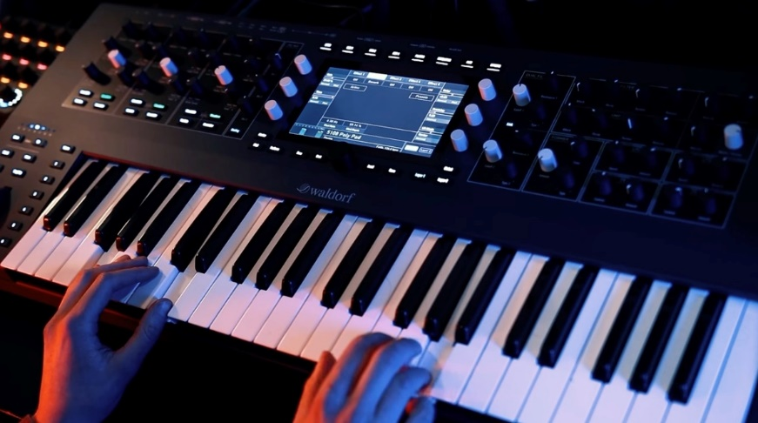

Pitch Wheel: Bending the Melody:

For those yearning for expressive melodic bends, the dedicated Pitch Wheel message offers a virtual joystick for your musical desires. With its high-resolution control, you can soar above the notes, adding a soulful vibrato or a dramatic glissando, bending the very fabric of your melody.

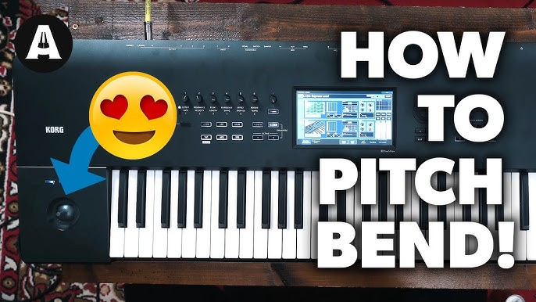

System Messages: The Conductor's Baton:

Messages starting with F0 through FF form a hidden orchestra within your MIDI setup. These system messages operate beyond individual channels, acting as the conductor's baton, coordinating the entire ensemble. They ensure smooth synchronization, trigger sequencers, reset hardware, and even retrieve vital information from connected devices.

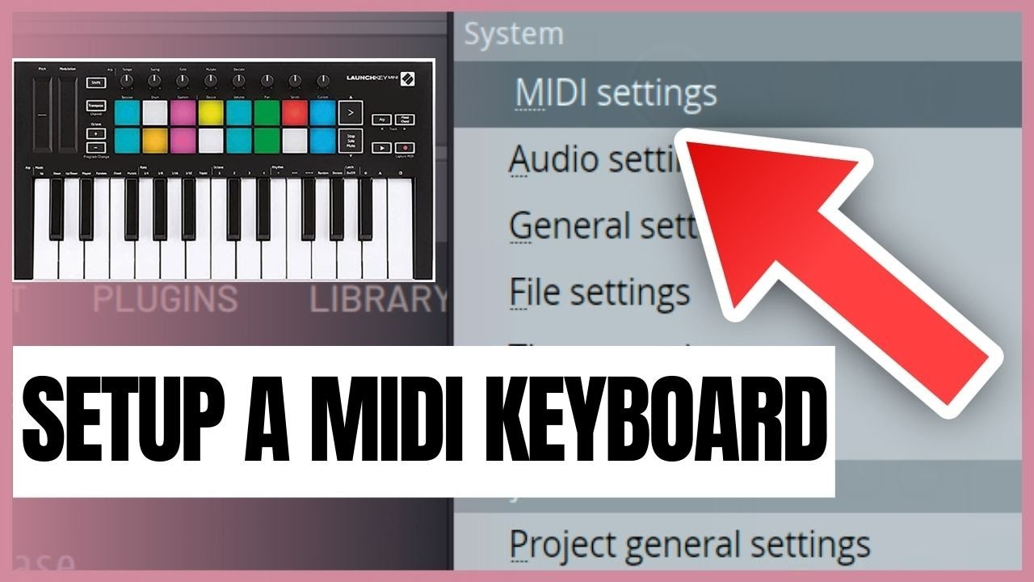

Active Sensing: Keeping the Pulse:

Imagine a constant rhythm keeping the MIDI orchestra in sync. Many controllers send out Active Sensing messages, acting like a steady heartbeat, signaling their presence and ensuring uninterrupted communication within the system.

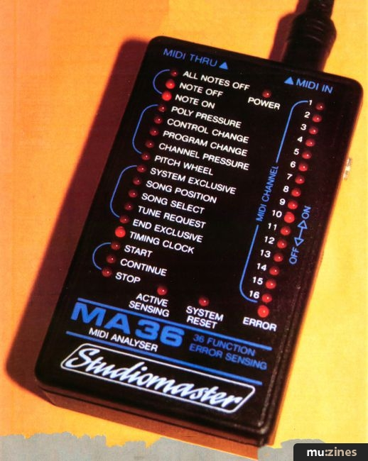

System Exclusive: Secret Handshakes:

For delving into the deepest corners of your synthesizer's sonic palette, System Exclusive messages offer a manufacturer-specific handshake. These messages carry chunks of data, like new voice definitions, in a format understood by its creator.

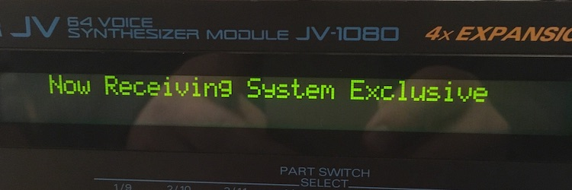

While staying device-independent might mean avoiding them, for adventurous musicians, they unlock a treasure trove of sonic possibilities, allowing you to craft custom voices and breathe new life into your synthesizer.

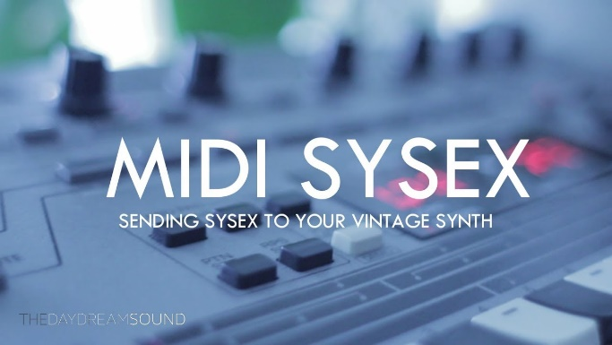 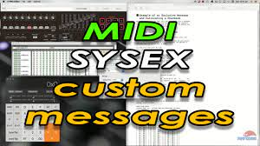

MIDI Files: Capturing the Performance:

Imagine bottling the essence of a musical performance. MIDI files do just that, capturing a collection of MIDI messages along with their timing information. These files then become musical blueprints, ready to be brought to life on other instruments or software, sharing the joy of your creation with the world.

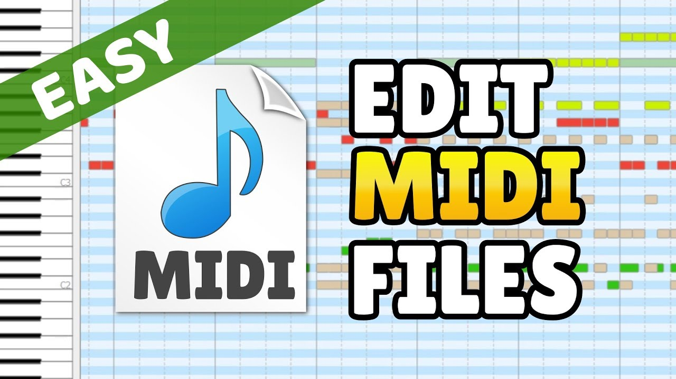

By venturing beyond the surface of Note On and Program Change, we gain a deeper understanding of MIDI's expressive power. These messages become tools in our hands, allowing us to sculpt sound, bend melodies, and orchestrate sonic landscapes. So, go forth, explore the nuances of MIDI messages, and let your music bloom in a rich tapestry of sound and emotion.

This journey through the hidden depths of MIDI messages expands your knowledge and empowers you to craft truly expressive and dynamic music. Remember, the orchestra is within your reach, waiting to be conducted by your understanding and creativity.

DELVING INTO MIDI SEQUENCING: ORCHESTRATING MUSIC WITH CODE

Communicating with MIDI Devices: A Low-Level Symphony

While MIDI files offer a way to capture and share musical performances, the true magic of MIDI lies in its ability to control instruments and create music in real-time.

This is where the low-level MIDI API enters the stage, providing a direct line of communication with MIDI devices.

Opening the Stage Door: midiOutOpen

To begin your MIDI journey, you'll first need to establish a connection with the desired MIDI output device, whether it's an internal synthesizer or an external instrument. Here's how you use the midiOutOpen function:

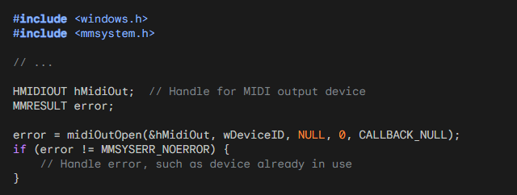

After calling midiOutOpen to open the MIDI output device, it is important to handle any potential errors that may occur. Error handling allows you to gracefully respond to issues that may arise, such as the MIDI device already being in use or being unavailable.

In the provided code snippet, the error variable is used to capture the return value of midiOutOpen.

If error is not equal to MMSYSERR_NOERROR, it indicates that an error has occurred during the attempt to open the MIDI output device.

Handling errors typically involves taking appropriate actions based on the specific error code returned. For example, you might display an error message to the user, log the error for debugging purposes, or implement a fallback strategy.

If the error code is MMSYSERR_ALLOCATED, it means that the MIDI output device is already in use by another application or process. In this case, you might want to inform the user that the device is unavailable and allow them to try again later or select a different device if available.

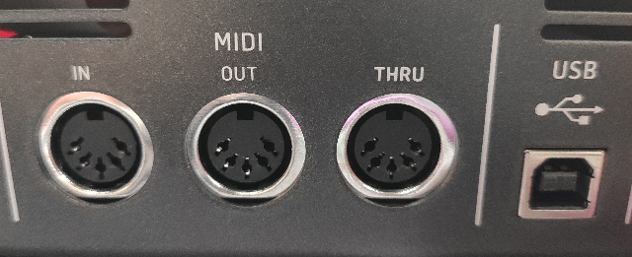

If the error code is MMSYSERR_BADDEVICEID, it indicates that the specified device ID is invalid. This could happen if the device ID provided in wDeviceID is out of range or does not correspond to a valid MIDI output device on the system. You can display an error message to the user informing them of the invalid device ID and allow them to select a different device.

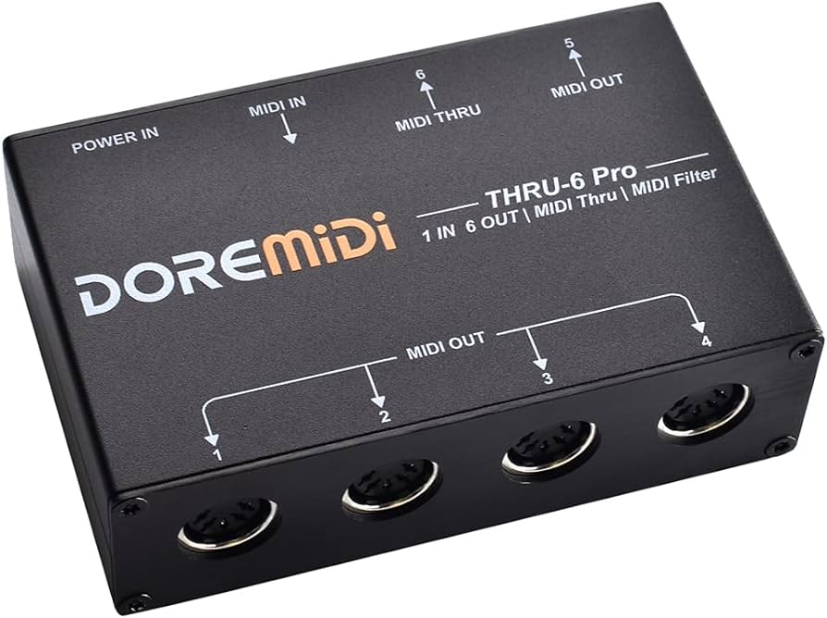

If the error code is MMSYSERR_NODRIVER, it suggests that there is no driver installed for the MIDI output device. You can inform the user that the MIDI device is not supported or that they need to install the appropriate driver for the device to work correctly.

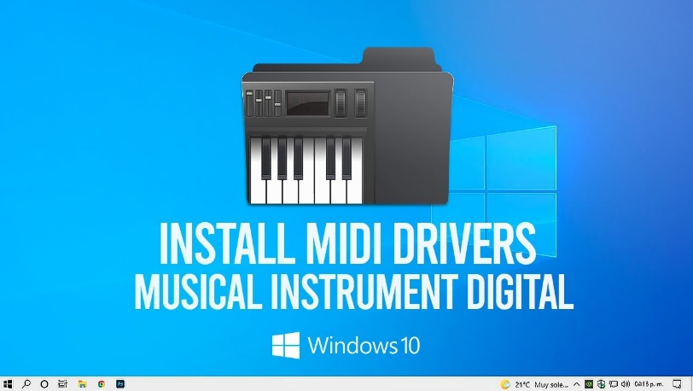

These are just a few examples of how you can handle errors when opening a MIDI output device. The specific actions you take will depend on the requirements of your application and the desired user experience. It's important to provide informative error messages and handle errors gracefully to ensure a smooth user experience when working with MIDI devices.

Sending Musical Messages: midiOutShortMsg

Once the stage is set, you can start sending MIDI messages to create music! Here's how you use the midiOutShortMsg function:

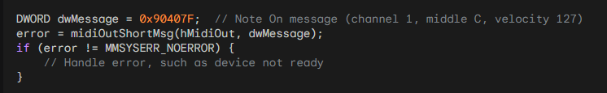

With the stage set and the MIDI output device open, you can start sending MIDI messages to create music. One way to do this is by using the midiOutShortMsg function. This function allows you to send a MIDI message in the form of a 32-bit DWORD to the MIDI output device.

In the provided code snippet, a DWORD variable named dwMessage is used to store the MIDI message. The message represents a "Note On" event on channel 1, with middle C as the note (0x40) and a velocity of 127 (0x7F). The status byte (0x90) indicates a Note On event on channel 1, and the most significant byte is set to 0.

After composing the MIDI message, you can call midiOutShortMsg to send it to the MIDI output device specified by the hMidiOut handle. If the function call returns an error code other than MMSYSERR_NOERROR, it indicates that there was an issue sending the MIDI message.

Handling errors when sending MIDI messages is essential to ensure the smooth operation of your application. Possible error scenarios include the MIDI device not being ready, the device becoming disconnected, or other system-level issues.

You should handle these errors appropriately, which may involve displaying an error message to the user, logging the error for further investigation, or taking any necessary recovery actions.

It's important to note that the provided code snippet demonstrates sending a "Note On" message, but MIDI offers a wide range of message types for various musical actions. For example, you can explore messages for actions such as changing programs/instruments, controlling pitch bend, altering control parameters, and more. Understanding and utilizing different MIDI messages will allow you to create dynamic and expressive musical experiences.

Once you have finished sending MIDI messages and no longer need the MIDI output device, it is important to close it using the midiOutClose function. This ensures that the resources associated with the device are properly released.

By embracing the low-level capabilities of MIDI and utilizing functions like midiOutShortMsg, you gain the power to compose and conduct your own MIDI symphonies.

You can send precise commands to MIDI devices, shaping and controlling the musical experience to your desired vision.

Whether you're creating simple melodies or orchestrating complex musical arrangements, MIDI provides a flexible and powerful foundation for your musical endeavors. Let the music flow and enjoy the creative possibilities that MIDI offers!

BACHTOCC.C PROGRAM STRUCTURE:

WinMain Function:

The WinMain function serves as the entry point for the Windows application.

It initializes the window class, creates the main window for MIDI playback, and enters the main message loop.

Parameters include hInstance (handle to the current instance of the application), hPrevInstance (historical instance, no longer used), szCmdLine (command-line parameters), and iCmdShow (initial window display state).

WndProc Function:

The WndProc function is the window procedure that processes messages for the main window.

It handles messages such as WM_CREATE for initialization, WM_TIMER for timing events, and WM_DESTROY for window destruction.

In the WM_CREATE case, it opens the MIDIMAPPER device and sends Program Change messages to set the instrument to "Church Organ."

The function also manages the polyphonic playback logic, note sequencing, and MIDI messages.

MidiOutMessage Function:

The MidiOutMessage function encapsulates the creation and sending of MIDI messages.

It takes parameters such as the MIDI output handle (hMidi), MIDI status, channel, data1, and data2.

It constructs a DWORD message using bitwise operations and sends the MIDI message using midiOutShortMsg.

MIDI FUNCTIONALITY:

MidiOutMessage Function:

This function is crucial for generating MIDI messages.

It takes the specified parameters and constructs a DWORD value representing a MIDI message using bitwise operations.

The resulting message is sent to the MIDI output device using the midiOutShortMsg function.

WM_CREATE Case in WndProc:

In the WM_CREATE case, the program initializes MIDI functionality.

It opens the MIDIMAPPER device using midiOutOpen, which establishes communication with the MIDI output device.

Program Change messages (0xC0) are then sent to set the instrument to "Church Organ" on both channel 0 and channel 12.

These components collectively form the program's structure and MIDI functionality. The program creates a window, sets up MIDI communication, and initiates playback of the first bar of Bach's Toccata in D Minor using polyphonic MIDI sequencing. The use of Program Change messages allows the selection of a specific instrument for playback, enhancing the musical experience.

NOTE SEQUENCING:

Static Array (noteseq):

The program incorporates a static array named noteseq to represent the note sequence of the first bar of Bach's Toccata in D Minor.

Each entry in noteseq holds information about the note duration (iDur) and two simultaneous notes (iNote[0] and iNote[1]).

This structured array serves as a musical score, defining when and which notes should be played during the polyphonic playback.

Duration and Simultaneous Notes:

* iDur represents the duration of the note in milliseconds, indicating how long a note should be held.
* iNote[0] and iNote[1] contain the MIDI note numbers of two simultaneous notes to create a polyphonic effect.
* The inclusion of simultaneous notes allows for the representation of chords or harmonies in the musical sequence.

POLYPHONIC PLAYBACK:

Two-Note Polyphony:

The program employs a polyphonic playback mechanism that supports a two-note polyphony.

This means that the musical sequence can include two simultaneous notes, enhancing the richness of the generated sound.

MIDI Messages for Playback:

The polyphonic playback is achieved through the generation of MIDI Note On and Note Off messages.

When a note is to be played (Note On), the program sends MIDI messages with the appropriate note numbers and velocity.

Conversely, when a note is to be stopped (Note Off), corresponding MIDI messages are sent with a velocity of 0, indicating the release of the note.

Timing with WM_TIMER Case:

The WM_TIMER case in the WndProc function is crucial for managing the timing of note playback.

It handles the progression through the noteseq array, triggering the Note On and Note Off messages at specific intervals based on the defined note durations.

The use of a timer ensures accurate timing, creating a seamless musical experience during playback.

Dynamic Note Sequencing:

The program dynamically advances through the noteseq array, playing the specified notes and maintaining the polyphonic structure.

As each note's duration expires, the program proceeds to the next set of notes in the sequence, creating a fluid and dynamic musical output.

In summary, the note sequencing and polyphonic playback mechanisms in the program work cohesively to interpret and translate the musical score (noteseq array) into a real-time, polyphonic MIDI performance. The use of simultaneous notes and accurate timing enhances the overall musicality of the generated sound during playback.

TIMER HANDLING:

SetTimer Function:

The SetTimer function is employed to establish a timer, which triggers the WM_TIMER case at regular intervals.

In this program, it ensures the advancement through the note sequence, facilitating polyphonic playback.

The timer is set with a specified interval, and the WM_TIMER case in the WndProc function handles the events triggered by this timer.

KillTimer Function:

The KillTimer function is used to stop the timer when the note sequence is complete.

After the timer is killed, the program proceeds to close the MIDI output and exit gracefully.

This mechanism ensures that the program concludes its musical playback and cleans up resources appropriately.

WINDOW PROCEDURE:

WndProc Function:

The WndProc function serves as the window procedure, handling various Windows messages to control program behavior.

Messages such as WM_CREATE, WM_TIMER, and WM_DESTROY are managed within this function.

WM_CREATE Case:

In the WM_CREATE case, the program initializes the MIDI output device.

It opens the MIDIMAPPER device, sends Program Change messages to set the instrument to "Church Organ," and establishes the initial state for MIDI playback.

Additionally, it sets the timer to initiate polyphonic note sequencing.

WM_TIMER Case:

The WM_TIMER case is crucial for managing the timing of note playback.

It handles the progression through the note sequence, triggering MIDI Note On and Note Off messages at specific intervals based on the defined note durations.

The dynamic nature of the WM_TIMER case ensures accurate timing for a seamless musical experience during playback.

WM_DESTROY Case:

In the WM_DESTROY case, the program resets and closes the MIDI output.

The midiOutReset function resets the MIDI output, and midiOutClose closes the MIDI output device.

Finally, the program posts a quit message to exit the application gracefully.

Window Creation:

The program creates a window with a specified title and dimensions using the CreateWindow function.

The window is set to play the Bach Toccata when it is created, initiating the MIDI playback.

Window Destruction:

Upon window destruction (handled in WM_DESTROY case), the program resets the MIDI output using midiOutReset and closes the MIDI output device with midiOutClose.

Proper cleanup ensures that resources are released, providing a smooth exit for the program.



In summary, the program seamlessly combines Windows GUI functionality with MIDI sequencing. It creates a window for MIDI playback, handles note sequencing with precise timing using timers, and ensures proper cleanup upon program termination. The integration of Windows messages and MIDI functionality results in a cohesive and responsive musical experience.

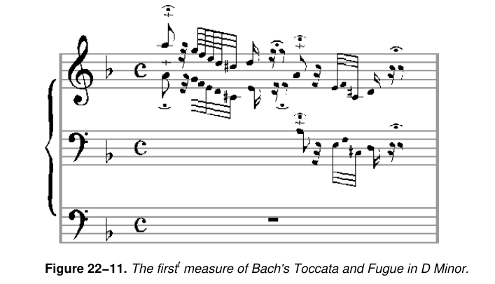

Limitations of Windows Timer:

* BACHTOCC demonstrates playing music using the Windows timer, but the approach has limitations.
* The Windows timer, based on the system clock, lacks the resolution required for accurate music reproduction.
* Asynchronous and timing issues may occur, affecting the quality of music playback.

Alternative Timer Functions:

* Windows provides supplementary timer functions with the prefix "time" for improved resolution (as low as 1 millisecond).
* These functions can be utilized for accurate timing when working with low-level MIDI output functions.

KBMIDI PROGRAM IN DEPTH

MIDI Communication:

1. midiOutOpen, midiOutShortMsg, and midiOutClose:

midiOutOpen: This function is used to open a connection to a MIDI output device. It requires parameters like the device identifier, callback function, and instance data. Handling the device identification and ensuring proper initialization is critical. Error checking is vital to address potential issues in device availability or opening.

midiOutShortMsg: Responsible for sending short MIDI messages to the specified MIDI output device. Understanding the structure of MIDI messages is essential, as this function is crucial for note on/off, control changes, and other real-time adjustments. Efficient management of MIDI channels, instruments, and control messages is imperative for accurate and expressive musical output.

midiOutClose: Closes the MIDI output device opened with midiOutOpen. Proper cleanup, resource release, and error handling are essential to ensure the graceful termination of the MIDI communication. Failing to close the device properly may lead to resource leaks and impact system stability.

2. Managing MIDI Channels, Instruments, and Control Messages:

MIDI Channels: MIDI communication involves 16 channels, each capable of carrying independent musical data. The program must manage channel assignments for different instruments and ensure that the right messages are sent to the correct channel.

Instruments (Voices): Assigning and handling different instruments or voices require a deep understanding of the General MIDI (GM) standard or any custom instrument mapping used by the program. This includes managing program change messages to switch between instruments dynamically.

Control Messages: Beyond note on/off messages, MIDI offers control messages for parameters like pitch bend, modulation, and expression. Proper handling of these messages is crucial for achieving nuanced and expressive musical output.

Window Procedure (WndProc):

1. Handling Keyboard Input:

Key Press/Release Events: WndProc must efficiently differentiate between key press and release events to trigger the corresponding actions. This involves tracking the state of each key and updating it dynamically.

Mapping Keyboard Input to MIDI Notes: The program likely includes a mapping mechanism to associate each key with a specific MIDI note. This mapping should consider factors like octaves and potentially handle different key layouts or configurations.

2. Menu Commands:

Dynamic Menu Creation: Depending on the available MIDI devices, the program dynamically creates menus. This involves querying the system for MIDI devices, obtaining their capabilities, and generating corresponding menu items. Error handling is crucial for situations where MIDI devices may not be available or accessible.

Menu Command Handling: WndProc processes menu commands triggered by user interactions. This includes actions like opening/closing MIDI devices, changing channels, and selecting instruments. Proper synchronization with MIDI communication functions ensures a seamless user experience.

3. Scrollbar Adjustments:

Horizontal and Vertical Scroll Bars: The program likely uses scroll bars to control parameters such as velocity and pitch bend. WndProc must respond to scroll bar messages, updating the associated parameters and reflecting these changes in real-time.

Visual Feedback: Inverting the color of keys when pressed provides visual feedback. Managing this visual representation involves handling WM_PAINT messages and updating the window's appearance dynamically.

In summary, both MIDI communication and the Window Procedure are intricate components requiring a deep understanding of real-time musical data processing, user interface interactions, and system-level resource management. The effective coordination of these elements is essential for creating a responsive and feature-rich MIDI synthesizer application.

MENU CREATION AND HANDLING:

1. Dynamic Menu Creation:

Enumerating MIDI Devices: The program likely uses MIDI API functions to enumerate available MIDI devices. This involves querying the system for MIDI input and output devices, obtaining device information, and dynamically creating menu items based on this information.

Device Capabilities: Each MIDI device may have unique capabilities. The program must extract and interpret these capabilities to provide meaningful menu options. For instance, displaying the available channels, instruments, or other device-specific settings in the menu.

Dynamic Menu Update: The program must dynamically update the menu whenever the number or configuration of MIDI devices changes. This includes scenarios where devices are added or removed during runtime.

2. Responding to Menu Commands:

Open/Close MIDI Devices: WndProc responds to menu commands related to opening and closing MIDI devices. Proper error handling is essential to address situations where a device cannot be opened or closed successfully, ensuring the stability of the MIDI communication.

Change Channels and Select Instruments: The program allows users to change MIDI channels and select instruments through menu commands. Coordination with MIDI communication functions is crucial to ensure that these changes are reflected in real-time, affecting the program's musical output.

KEYBOARD INPUT PROCESSING:

1. Mapping Keyboard Input to MIDI Notes and Octaves:

Key to Note Mapping: WndProc processes keyboard input, mapping each key to a corresponding MIDI note. This involves creating a mapping table that associates keys with specific note values, considering factors like the starting octave and potential octave adjustments.

Octave Adjustments: The program likely allows users to adjust the octave using modifiers like Shift and Ctrl. WndProc must interpret these modifier states and dynamically update the mapping, allowing users to play across multiple octaves with ease.

Visual Feedback: In addition to MIDI output, the program may provide visual feedback for pressed keys, enhancing the user experience. This involves updating the appearance of keys in the graphical user interface to reflect the current state of each key, providing a responsive and immersive interaction.

2. Managing Key States:

Key Press and Release Events: WndProc efficiently manages key press and release events, maintaining the state of each key. This involves handling the WM_KEYDOWN and WM_KEYUP messages, updating the internal key state, and triggering the corresponding MIDI note events.

Modifiers (Shift, Ctrl): Recognizing and interpreting modifier keys is crucial for implementing advanced features like octave adjustments. WndProc tracks the state of these modifiers, dynamically adjusting the mapping table to accommodate changes in octave settings during live play.

In summary, effective menu creation and keyboard input processing are integral to the overall functionality and user experience of a MIDI synthesizer program. These components require a combination of system-level interaction, real-time data processing, and dynamic user interface updates to deliver a seamless and expressive musical environment.

SCROLL BAR CONTROLS:

1. Incorporating Horizontal and Vertical Scroll Bars:

Parameter Control: The program uses scroll bars to allow users to control parameters like velocity and pitch bend. Horizontal and vertical scroll bars likely correspond to different parameters, providing a visual and interactive way for users to adjust these settings dynamically.

Mapping to MIDI Parameters: Each scroll bar's position is mapped to specific MIDI parameters. For example, the vertical scroll bar might control pitch bend, while the horizontal scroll bar adjusts velocity. Ensuring a smooth and intuitive mapping is crucial for user-friendly parameter manipulation.

2. Handling Scroll Bar Messages:

Message Processing: WndProc processes messages related to scroll bar interaction, such as SB_LINEUP, SB_LINEDOWN, SB_THUMBPOSITION, etc. These messages signify user actions like scrolling, dragging the thumb, or clicking on the scroll bar arrows.

Real-time Updates: The program must update MIDI parameters in real-time based on scroll bar interactions. This involves translating the scroll bar positions into meaningful changes in velocity and pitch bend, ensuring that the musical output reflects the user's adjustments accurately.

GRAPHICS AND DRAWING:

1. Drawing Individual Keys on the Window:

Key Positioning and Dimensions: The program dynamically calculates and positions individual keys on the window, considering factors like key size, spacing, and overall layout. This is crucial for creating an accurate and visually appealing representation of the musical keyboard.

Labeling Keys: Each key is labeled based on its MIDI note value. This labeling provides users with a clear visual reference, aiding in navigation and musical expression. Labels may include note names (C, D, E, etc.) and octave numbers.

2. Inverting Color of Keys When Pressed:

Visual Feedback for Key Press: When a key is pressed, the program inverts the color of the corresponding graphical representation. This visual feedback enhances the user experience, providing a responsive and intuitive connection between the virtual interface and the user's actions.

Dynamic Color Handling: The program dynamically manages the color state of keys, ensuring that the inversion occurs only when a key is actively pressed. This involves handling key press and release events, updating the graphical representation accordingly.

User Engagement: The visual feedback not only serves a functional purpose but also contributes to the overall engagement and immersion of the user in the virtual musical environment. It mimics the tactile response of a physical keyboard, enhancing the sense of interaction and control.

In summary, the incorporation of scroll bar controls and the thoughtful design of graphics and drawing elements are essential aspects of your MIDI program. These components contribute to the program's usability, real-time responsiveness, and visual appeal, creating a rich and enjoyable experience for users interacting with virtual musical instruments.

GRAPHICS AND DRAWING:

1. Drawing Individual Keys on the Window:

Position Calculation: The program employs precise algorithms to calculate the positions of individual keys dynamically. This involves considering factors like the total number of keys, their dimensions, and the overall layout of the virtual keyboard. The goal is to create an accurate and visually pleasing representation of the musical keyboard within the application window.

Dimensional Considerations: Each key is drawn with careful attention to its dimensions, ensuring that they are proportional and visually coherent. This contributes to the realism and aesthetics of the virtual instrument, providing users with a visually intuitive representation that mirrors the physical attributes of a traditional musical keyboard.

Labeling for Reference: Keys are labeled based on their MIDI note values, incorporating note names and octave numbers. This labeling enhances user understanding and navigation, allowing musicians to easily identify and locate specific notes on the virtual keyboard.

2. Inverting the Color of Keys When Pressed:

Dynamic Color Handling: The program dynamically manages the color state of keys in response to user interactions. When a key is pressed, its color is inverted, providing immediate and intuitive visual feedback. This feature mimics the tactile response of physical keys, enhancing the user's sense of connection and control.

Visual Feedback for User Engagement: The color inversion serves not only a functional purpose but also contributes to user engagement. It creates a responsive and interactive environment, reinforcing the connection between the user's actions and the virtual instrument's visual representation. This feedback is crucial for musicians who rely on visual cues during performance and composition.

RESOURCE MANAGEMENT:

1. Properly Opening and Closing MIDI Devices:

MIDI API Functions: The program utilizes MIDI API functions, such as midiOutOpen and midiOutClose, to establish and terminate connections with MIDI devices. Proper handling of these functions ensures the reliable and efficient communication between the software and external hardware.

Error Handling: Robust error-handling mechanisms are implemented to address potential issues during device opening and closing. This includes checking return values, diagnosing errors, and providing informative messages to users in case of failures. This proactive approach enhances the overall stability and reliability of the MIDI communication.

2. Managing Resources and Handling Potential Errors:

Resource Allocation: The program efficiently manages system resources, such as memory and processing power, to ensure optimal performance. This involves judicious allocation and deallocation of resources, preventing memory leaks and optimizing the overall efficiency of the application.

Error Resilience: Robust error-handling strategies are integrated throughout the code to anticipate and address potential errors gracefully. This includes scenarios such as device unavailability, resource exhaustion, or unexpected runtime issues. By handling errors systematically, the program enhances its resilience and user experience.

CODE ORGANIZATION:

1. Using Structures and Constants for Organization:

Structured Data Representation: The program employs structures to organize MIDI instrument families, instruments, and key mappings. This structured approach enhances code readability and maintainability by encapsulating related data into cohesive units. Each structure likely contains essential information such as instrument names, MIDI channels, and key assignments.

Constants for Configuration: Constants are used to define fixed values that remain unchanged during program execution. They are employed to represent parameters like instrument families, ensuring consistency and facilitating easy updates. This modular organization improves code comprehensibility and simplifies future modifications.

Enhanced Modularity: By utilizing structures and constants, the code achieves a modular and organized structure. This design choice enhances scalability, allowing for the seamless addition of new instrument families or modifications to existing ones. It reflects a thoughtful approach to code organization, promoting clarity and ease of maintenance.

ERROR HANDLING:

Limited Error Handling:

Critical Error Messaging: The current error-handling approach employs basic message boxes for critical errors. While effective for conveying essential information, it's crucial to consider expanding error handling to cover a broader range of scenarios. This can include non-critical errors, providing users with informative messages to aid troubleshooting and ensuring a more user-friendly experience.

Logging Mechanism: Implementing a logging mechanism can enhance error tracking and debugging. Logging critical events and errors to a file allows developers to analyze issues post-execution, facilitating quicker identification and resolution. This proactive approach improves the overall robustness of the application.

UNDERSTANDING MIDI MESSAGES:

Knowledge of MIDI Message Formats:

Message Structure Familiarity: The code demonstrates a profound understanding of MIDI message formats and their interpretation. This is evident in the effective use of MIDI API functions, such as midiOutShortMsg, which is pivotal for sending MIDI messages to devices. The correct construction and parsing of MIDI messages indicate a high level of proficiency in MIDI communication.

Channel and Control Handling: Managing MIDI channels, instruments, and control messages involves intricate knowledge of MIDI message structures. The program showcases competence in handling complex MIDI messages, ensuring precise control over parameters like instrument selection and channel configuration.

Closing Thoughts:

In conclusion, the provided code serves as an exemplary demonstration of expertise in WinAPI development, MIDI communication, and user interface design tailored for a MIDI synthesizer application. It stands as a robust foundation for a functional and interactive program, showcasing meticulous attention to detail in various aspects.

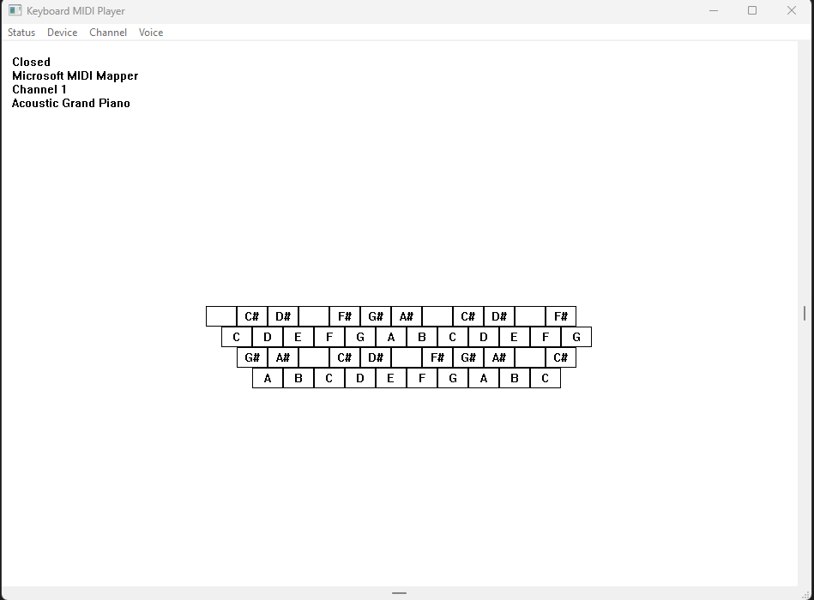

The code's strengths lie in its:

* Efficient MIDI Communication: Leveraging MIDI API functions for device interaction and demonstrating a nuanced understanding of MIDI message formats.
* User Interface Design: Incorporating dynamic elements like dynamic menu creation, keyboard input processing, scroll bar controls, and visually engaging graphics.
* Code Organization: Utilizing structures and constants for a modular and organized codebase, enhancing readability and maintainability.
* While there is room for refining error handling and potentially expanding features, the code overall represents a commendable achievement in WinAPI development, catering to the intricate demands of MIDI synthesis and user interaction. It stands as a testament to the developer's proficiency and creativity in crafting a compelling musical application.

More Explanation:

Keyboard Mapping:

* The program maps the computer keyboard to traditional piano or organ keys.
* The Z key plays an A at 110 Hz, and the keyboard spans 3 octaves from the bottom row to the top two rows.
* The Ctrl key drops the entire range by 1 octave, while the Shift key raises it by 1 octave, providing an effective range of 5 octaves.

MIDI Device Management:

* To hear sound, users need to select "Open" from the Status menu to open a MIDI output device.
* Pressing a key sends a MIDI Note On message, and releasing the key generates a Note Off message.
* "Close" from the Status menu allows users to close the MIDI device without terminating the program.
* The "Device" menu lists installed MIDI output devices, including MIDI Out ports and the MIDI Mapper device.

MIDI Channel and Voice Selection:

* The "Channel" menu lets users select a MIDI channel from 1 through 16, with channel 1 as the default.
* The "Voice" menu offers a selection of 128 instrument voices from the General MIDI specification, divided into 16 families with 8 instruments each.
* These voices, known as melodic voices, correspond to different pitches based on MIDI key numbers.

Percussion Instruments:

* The "Channel" menu, when set to channel 10, allows users to play nonmelodic percussion instruments.
* Selecting the first instrument voice (Acoustic Grand Piano) from the "Voice" menu enables different percussion sounds for each key.

Scroll Bars:

* Horizontal and vertical scroll bars control parameters like note velocity and pitch bend.
* The horizontal scroll bar, due to the non-velocity-sensitive nature of the PC keyboard, adjusts the volume of played notes.

Vertical Scroll Bar and Pitch Bend:

* The vertical scroll bar in KBMIDI is responsible for generating a MIDI message known as "Pitch Bend."
* Users can press down one or more keys and manipulate the vertical scroll bar thumb with the mouse.
* Raising the scroll bar thumb increases the frequency of the note, while lowering it decreases the frequency. Releasing the scroll bar returns the pitch to normal.

Considerations for Scroll Bars:

* Manipulating scroll bars interrupts the program's message loop for keyboard messages.
* If a key is pressed and the scroll bar is manipulated before releasing the key, the note will continue to sound.
* It's advised not to press or release keys during scroll bar manipulation, and caution is needed when interacting with menus.

Handling Stuck Notes:

* If notes get "stuck" and continue to sound after release, pressing the Esc key sends 16 "All Notes Off" messages to stop the sounds.

Menu and Resource Handling:

* KBMIDI creates its menu from scratch without a resource script.
* Device names are obtained from the midiOutGetDevCaps function, and instrument voice families and names are stored in a program data structure.

Pitch Bend Message:

* KBMIDI has short functions for simplifying MIDI messages, including the Pitch Bend message.
* The Pitch Bend message uses two 7-bit values to form a 14-bit pitch-bend level, where values between 0 and 0x1FFF lower the pitch, and values between 0x2001 and 0x3FFF raise the pitch.

MidiSetPatch and Device Changes:

* When selecting "Open" from the Status menu, KBMIDI calls midiOutOpen for the selected device and, if successful, calls its MidiSetPatch function.
* Changing the device requires closing the previous device if necessary and reopening the new device, with a call to MidiSetPatch when changing the MIDI device, channel, or instrument voice.

WM_KEYUP and WM_KEYDOWN Messages:

* KBMIDI processes WM_KEYUP and WM_KEYDOWN messages to turn notes on and off.
* A data structure maps keyboard scan codes to octaves and notes, used for both MIDI note generation and drawing keys on the window.

Scroll Bar Processing:

* Horizontal scroll bar processing involves storing the new velocity level and setting the new scroll bar position.
* Vertical scroll bar processing for pitch bend involves handling SB_THUMBTRACK and SB_THUMBPOSITION commands, setting the scroll bar position to its middle level and calling MidiPitchBend with a value of 8192.

DRUM.C PROGRAM

Header File (DRUMTIME.H):

NUM_PERC: This constant represents the number of percussion instruments in the drum machine, and it is set to 47. This value is crucial for defining the size of arrays or data structures related to percussion instruments.

WM_USER_NOTIFY, WM_USER_FINISHED, WM_USER_ERROR: These are custom Windows messages. Custom messages allow communication between different parts of the program, such as notifying the user interface about events in the MIDI sequence.

DRUM structure: This structure encapsulates various parameters essential for the drum machine. It includes fields for tempo, velocity, the number of beats, and arrays storing percussion sequences. The structure serves as a container for organizing and passing these parameters within the program.

Functions:

DrumSetParams: This function takes a pointer to a DRUM structure and sets its parameters based on the provided values. It is responsible for initializing or updating the drum machine configuration.

DrumBeginSequence: Initiates the MIDI sequence for the drum machine. This function likely involves setting up MIDI devices and starting the playback of the programmed drum sequence.

DrumEndSequence: Terminates the MIDI sequence for the drum machine. This function could involve stopping MIDI playback and performing cleanup tasks.

Main Program (DRUM.C):

The program includes various standard Windows and C library headers, indicating its reliance on fundamental functionalities provided by the operating system and the C language.

The inclusion of a resource file header suggests that the program utilizes external resources (possibly graphical or textual) that are managed separately.

Global Variables:

* bNeedSave: This flag serves as a boolean indicator, likely tracking whether there are unsaved changes in the drum sequence. It influences user prompts and decisions related to saving modifications.
* drum: An instance of the DRUM structure, holding parameters and sequences for the drum machine. This variable likely represents the state of the drum machine throughout the program.
* hMenu: This variable holds the handle to the program's menu. Menu handles are essential for manipulating and updating menu items during runtime.
* iTempo: Represents the current tempo setting of the drum machine. It is a numerical value determining the speed of the drum sequence.
* szFileName, szTitleName: These strings store the current file name and title, respectively. They are essential for tracking the state of the loaded or saved file.
* cxChar, cyChar: These variables represent the width and height of characters in dialog units. They are likely used for calculating and specifying the layout and dimensions of GUI elements.
* hInst: The handle to the program instance is crucial for interacting with the Windows operating system, especially during window creation and message processing.

These global variables collectively maintain the program's state, user interface elements, and information related to the drum machine's configuration and sequence. They play pivotal roles in controlling the program's behavior and ensuring proper interaction with the user and the operating system.

WinMain Function:

The WinMain function serves as the program's entry point, orchestrating the initialization, window creation, and message processing. It follows a standard structure for Windows applications. Upon invocation, it registers the window class, creates the main window, and enters the message loop, where it awaits and dispatches messages.

The initialization section defines the window class (WNDCLASS structure) with specific attributes, such as window procedure (WndProc), cursor, background brush, and icon. The window class is then registered with the system using RegisterClass.

Subsequently, the main window is created using CreateWindow, and its handle is stored in hwnd. The window is then displayed using ShowWindow, and the message loop is initiated with UpdateWindow.

This function encapsulates the essential setup steps for a typical Windows application, ensuring that the program is ready to receive and respond to user interactions through the window.

WndProc Function:

The WndProc function serves as the window procedure, handling various window messages to manage the program's behavior.

It encompasses a switch statement that processes messages such as WM_CREATE, WM_COMMAND, WM_LBUTTONDOWN, WM_HSCROLL, WM_VSCROLL, WM_PAINT, WM_CLOSE, and others.

In response to WM_COMMAND, menu commands trigger specific actions, such as creating a new file, opening an existing file, saving, and handling sequence playback.

Mouse events (WM_LBUTTONDOWN) and scroll bar adjustments (WM_HSCROLL, WM_VSCROLL) are managed to facilitate user interaction, such as setting the tempo and velocity or selecting beats in the drum sequence. Additionally, WM_PAINT is responsible for rendering the graphical elements on the window.

Custom messages like WM_USER_NOTIFY and WM_USER_FINISHED are used for internal communication, possibly related to MIDI sequence notifications and error handling.

The WndProc function acts as the central hub for interpreting and responding to various events, ensuring the program's responsiveness and maintaining a coherent user interface.

AboutProc Function:

The AboutProc function is a dialog procedure specifically designed for the About box.

It handles messages related to the initialization of the dialog (WM_INITDIALOG) and user commands, such as clicking the OK button (IDOK).

The function returns TRUE for messages it processes and FALSE otherwise. Its primary purpose is to display information about the program or the development team in response to user interaction with the About box.

DrawRectangle Function:

The DrawRectangle function is responsible for rendering a rectangle on the window, representing a beat in the drum sequence.

It receives parameters such as the device context (HDC), coordinates (x and y), and bitmasks (dwSeqPerc and dwSeqPian) indicating the status of percussion instruments for a given beat.

The function determines the color of the rectangle based on the instrument status and uses Rectangle to draw it.

This function plays a crucial role in visually representing the state of the drum sequence within the window.

ErrorMessage Function:

The ErrorMessage function displays an error message box to the user. It takes parameters such as the window handle (hwnd), an error message (szError), and the current file name (szTitleName).

The error message is constructed using wsprintf, including the current file name if available, and then presented to the user via MessageBox. This function also utilizes MessageBeep to provide an audible cue for the error.

DoCaption Function:

The DoCaption function sets the window caption based on the current file name. It utilizes wsprintf to construct the caption string, incorporating the file name or indicating that the file is untitled.

The resulting string is then set as the window caption using SetWindowText. This function ensures that the window title accurately reflects the state of the loaded or saved file.

AskAboutSave Function:

The AskAboutSave function prompts the user with a message box, asking whether to save changes before proceeding with certain actions.

It constructs the message using wsprintf, including the current file name, and utilizes MessageBox to interact with the user.

The function returns the user's choice (yes, no, or cancel), influencing subsequent program behavior based on the response.

These functions collectively contribute to the core functionality and user interaction of the drum machine program, providing a well-structured and responsive user interface.

In summary, the "DRUM" program exhibits a well-organized structure and functionality. The program flow can be outlined as follows:

Initialization:

* The program initializes the parameters of the drum machine, including tempo, velocity, and the number of beats.
* GUI elements, such as scroll bars and menu items, are set up to provide user interaction.

User Interactions:

* The program handles various user interactions through the window procedure (WndProc), responding to menu commands, mouse events, and scroll bar adjustments.
* Menu commands allow users to perform actions such as creating a new file, opening/saving files, starting/stopping sequences, and displaying an About box.
* Mouse interactions, particularly left and right button clicks, modify the drum sequences, enabling users to create and edit rhythmic patterns.
* Scroll bar adjustments control parameters like tempo and velocity, providing real-time adjustments to the playback characteristics.

Sequence Modification:

* The drum sequences are modified based on user interactions, with each beat in the sequence representing a percussion instrument.
* The DrawRectangle function visually represents the state of the drum sequence, ensuring a clear and intuitive display of the rhythm.

Custom Messages:

* Custom Windows messages (WM_USER_NOTIFY, WM_USER_FINISHED, WM_USER_ERROR) are employed for specific functionalities, possibly related to MIDI sequence notifications and error handling.

File I/O Operations:

* Custom functions for file I/O operations (DrumFileOpenDlg, DrumFileRead, DrumFileWrite) are used to open, read, and write drum machine configurations. These functions contribute to the persistence of user-created drum sequences.

Sequence Control:

* Functions like DrumBeginSequence and DrumEndSequence manage the initiation and termination of MIDI sequences. These functions likely play a role in controlling the playback of drum sequences.

Error Handling:

* The ErrorMessage function provides a mechanism for displaying informative error messages to the user, enhancing the program's usability by offering insights into potential issues.

About Box:

* The AboutProc function serves as the dialog procedure for the About box, allowing users to access information about the program or its developers.

This breakdown highlights the program's modular design, separating different aspects of functionality into distinct sections. The effective use of custom messages, functions, and clear user interactions contributes to a robust and user-friendly drum machine application.

DRUMFILE.C PROGRAM

The provided portion of code is from the "DRUMFILE.C" file, responsible for handling file input/output operations in the DRUM program. Let's break down the code into paragraphs, focusing on its structure and purpose.

Header Inclusions:

The code begins with the inclusion of necessary headers, namely <windows.h>, <commdlg.h>, and the custom headers for the drum program, "drumtime.h" and "drumfile.h." These headers provide essential functionalities for Windows programming and definitions specific to the DRUM program.

Global Variables and Definitions:

Following the header inclusions, the code declares and initializes global variables and definitions that are crucial for file handling. These include the OPENFILENAME structure (ofn), an array defining file filters (szFilter), and several strings identifying specific components in the DRUM file format.

File Handling Routines:

The code then defines routines related to file input/output operations. It initializes the OPENFILENAME structure (ofn) with appropriate values, including the file filter, default extension, and flags. The function DrumFileOpenDlg is designed to open a file dialog for selecting or creating DRUM files. It takes parameters such as the parent window handle, file name, and title name.

Function Details:

* ofn.hwndOwner = hwnd;: Sets the owner window for the file dialog.
* ofn.lpstrFilter = szFilter[0];: Specifies the file filter for DRUM files.
* ofn.lpstrFile = szFileName;: Sets the buffer to store the selected file name.
* ofn.nMaxFile = MAX_PATH;: Defines the maximum length of the file name.
* ofn.lpstrFileTitle = szTitleName;: Sets the buffer to store the file title.
* ofn.nMaxFileTitle = MAX_PATH;: Defines the maximum length of the file title.
* ofn.Flags = OFN_CREATEPROMPT;: Configures the file dialog to prompt for file creation if the selected file does not exist.
* ofn.lpstrDefExt = TEXT("drm");: Sets the default extension for DRUM files.

Return Statement:

The function returns the result of the GetOpenFileName function, indicating whether the user successfully selected or created a DRUM file.

This portion of the code establishes the framework for opening DRUM files through a file dialog, ensuring that the selected file adheres to the DRUM file format. It encapsulates the necessary configurations and behaviors for interacting with the file dialog in a Windows environment.

File Save Dialog Function (DrumFileSaveDlg):

The function initiates a file save dialog to allow the user to specify the name and location for saving a DRUM file.

It utilizes the OPENFILENAME structure (ofn) initialized with relevant parameters such as the owner window, file filter, default extension, and flags. The function returns a Boolean value indicating the success of the operation.

File Write Function (DrumFileWrite):

This function is responsible for writing the DRUM structure and associated information to a file. It takes as parameters the DRUM structure (pdrum) and the file name (szFileName).

The function begins by creating and opening a new file for writing using the Windows Multimedia I/O API (mmioOpen). It then proceeds to structure the file content with specific chunks and sub-chunks required for the DRUM file format.

File Structure Creation:

* The function starts by creating a "RIFF" chunk with a "CPDR" type, representing the top-level structure of a DRUM file.
* Within the "RIFF" chunk, it creates a "LIST" sub-chunk with an "INFO" type, encapsulating additional information about the file.
* Within the "INFO" chunk, it creates a sub-sub-chunk with an "ISFT" type, containing information about the software used to create the file.
* It writes the software information to the file and ascends from the "ISFT" sub-sub-chunk.
* The function also creates a sub-sub-chunk with an "ISCD" type, containing the current date.
* It writes the date information to the file and ascends from the "ISCD" sub-sub-chunk.
* The function then ascends from the "INFO" chunk.
* Next, it creates a "fmt " sub-chunk, representing the format of the data to follow, and writes the format information to the file.
* Following that, it creates a "data" sub-chunk and writes the DRUM structure to the file.

Error Handling and Cleanup:

The function handles errors during the file writing process, deleting the file if an error occurs. It uses specific error messages (szErrorNoCreate and szErrorCannotWrite) to communicate issues related to file creation and writing.

In summary, this code segment encapsulates the logic for saving DRUM data to a file. It ensures proper structuring of the file content according to the DRUM file format and includes error handling to manage potential issues during the file writing process.

Function Overview (DrumFileRead):

The function is designed to read DRUM data from a file specified by szFileName. It takes as parameters a pointer to the DRUM structure (pdrum) where the data will be stored.

File Reading Process:

The function starts by declaring local variables, including the DRUM structure (drum), an integer for the file format (iFormat), and an array of MMCKINFO structures (mmckinfo).

It initializes the MMCKINFO array and opens the specified file for reading using the Windows Multimedia I/O API (mmioOpen).

The function then searches for a "RIFF" chunk with a "DRUM" form-type, using mmioDescend and mmioStringToFOURCC. If not found, it returns an error indicating that the file is not a standard DRUM file.

Reading "fmt " Sub-chunk:

The function locates and descends into the "fmt " sub-chunk, verifying its size and reading the file format information. If the format is unsupported or cannot be read, it returns an appropriate error message.

It checks if the format is either 1 or 2, and if not, it returns an error indicating an unsupported format.

Reading "data" Sub-chunk:

The function then locates and descends into the "data" sub-chunk, verifying its size and reading the DRUM structure. If the size is incorrect or reading fails, it returns an error.

Conversion for Format 1:

If the file format is 1, the function performs a conversion by rearranging sequence data in the DRUM structure.

Closing the File and Returning:

Finally, the function closes the file using mmioClose and copies the read DRUM data to the provided pointer (pdrum).

Error Handling:

Throughout the process, the function incorporates error handling, closing the file and returning specific error messages in case of issues.

Let's summarize the key points:

Interface Overview:

* The program interface initially displays 47 percussion instruments on the left side, arranged in two columns.
* The right side contains a grid representing percussion sounds over time, with each instrument associated with a row and each column representing a beat.

Sequence Playback:

* Selecting "Running" from the Sequence menu attempts to open the MIDI Mapper device.
* A "bouncing ball" moves across the grid, playing percussion sounds for each beat.
* Left-clicking adds dark gray squares for percussion sounds, right-clicking adds light gray squares for piano beats, and both buttons together create black squares with both sounds.

Repeat Sign and Beats:

* Dots above the grid mark every 4 beats for easy reference.
* A repeat sign (:|) at the upper right corner indicates the sequence's length.
* Clicking above the grid places the repeat sign, and the sequence plays up to, but not including, the beat under the repeat sign.

Control Elements:

* Horizontal scroll bar controls velocity (affecting volume and, in some synthesizers, timbre).
* Vertical scroll bar controls tempo on a logarithmic scale, ranging from 1 second per beat at the bottom to 10 milliseconds per beat at the top.

File Management:

* The File menu allows saving and retrieving files with a .DRM extension, using the RIFF file format.

About and Stopped Options:

* The About option in the Help menu provides a brief summary of mouse usage and scroll bar functions.
* The Stopped option in the Sequence menu stops the music and closes the MIDI Mapper device after finishing the current sequence.

Multimedia Time Functions:

* In DRUM.C, the absence of calls to multimedia functions is highlighted, with the real-time functionality being delegated to the DRUMTIME module.
* The Windows timer, though simple, is deemed inadequate for time-critical applications like playing music.
* To address this, the multimedia API provides a high-resolution timer implemented through functions with the prefix "time."
* The multimedia timer works with a callback function running in a separate thread. Two critical parameters are specified: delay time and resolution. The resolution acts as a tolerable error, allowing flexibility in the actual timer delay.
* Before using the timer, obtaining device capabilities through timeGetDevCaps is recommended. This provides minimum and maximum resolution values, which can be used in subsequent timer function calls.
* The sequence involves calling timeBeginPeriod to set the required timer resolution, followed by setting a timer event using timeSetEvent. To stop events, timeKillEvent is employed. The multimedia timer is designed specifically for playing MIDI sequences and offers limited functionality for other purposes.

DRUMTIME Module:

* The DRUMTIME module is crucial for handling time-related operations in the DRUM program. It manages the multimedia timer, orchestrating events based on user interactions and MIDI sequence requirements.
* The DrumSetParams function in DRUM.C calls the equivalent function in DRUMTIME.C, passing a pointer to a DRUM structure.
* This structure contains essential parameters such as beat time, velocity, number of beats, and sequences for percussion and piano sounds. This information is crucial for setting up and modifying the drum sequences.
* DrumBeginSequence is invoked to initiate the MIDI sequence. It opens the MIDI Mapper output device, sets up the timer with specified resolution and delay, and selects instrument voices for percussion and piano.
* The DrumTimerFunc callback is at the heart of the timer functionality. It handles MIDI Note On/Off messages, updates the beat index, and triggers the next timer event.
* To conclude the sequence, DrumEndSequence is called, either ending it immediately (TRUE argument) or allowing it to complete the current cycle before termination (FALSE argument).
* This function manages the cleanup process, including killing the timer event, ending the timer period, sending "all notes off" messages, and closing the MIDI output port.

In summary, the Multimedia Time Functions and the DRUMTIME module work synergistically to provide accurate timing for playing MIDI sequences in the DRUM program. The modular design enhances code organization and readability, making the program efficient and responsive to user interactions.

The section you provided explains the RIFF (Resource Interchange File Format) file I/O in the DRUM program, detailing how the program saves and retrieves files containing information stored in the DRUM structure. The RIFF format is a tagged file format, where data is organized in chunks, each identified by a 4-character ASCII tag.

RIFF File Structure:

* Chunks: The RIFF file consists solely of chunks, each composed of a chunk type (4-character ASCII tag), chunk size (32-bit value indicating the size of the chunk data), and the actual chunk data. Chunks are word-aligned, and the chunk size does not include the 8 bytes required for the chunk type and size.
* RIFF and LIST Chunks: There are two special types of chunks - RIFF chunks and LIST chunks. A RIFF chunk is used for the overall file, and a LIST chunk is used to consolidate related sub-chunks within the file.

mmio Functions:

* The multimedia API includes 16 functions beginning with the prefix mmio, specifically designed for working with RIFF files.
* To open a file, mmioOpen is used. mmioCreateChunk creates a chunk, mmioWrite writes chunk data, and mmioAscend finalizes the chunk.
* Nested levels of chunks are maintained with multiple MMCKINFO structures associated with each level. In the DRUM program, three levels of chunks are used.
* The RIFF file begins with a RIFF chunk, starting with the string "RIFF" and a 32-bit value indicating the size of the file.

Writing RIFF File (DrumFileWrite):

* The function begins by creating the RIFF chunk using mmioCreateChunk with mmckinfo[0]. Subsequently, a LIST chunk is created within the RIFF chunk using mmckinfo[1], and an ISFT sub-chunk for software identification is created with mmckinfo[2].
* Further chunks like ISCD, "fmt," and "data" are created within the LIST chunk. mmioAscend is used to finalize each chunk and move to the next level.
* Finally, the size of the overall RIFF chunk is filled in with one last call to mmioAscend using mmckinfo[0]. mmioClose concludes the file-writing process.

Reading RIFF File (DrumFileRead):

* Reading involves using mmioRead instead of mmioWrite and mmioDescend instead of mmioCreateChunk. The process is similar to writing, but it descends into chunks to read data.
* The program can identify the format identifier and convert files written with an earlier format to the current one.

In summary, the DRUM program utilizes the RIFF file format and mmio functions for efficient and flexible file I/O operations. The use of chunks allows easy extensibility of the file format, and the mmio functions streamline the process of reading and writing these structured files.

That’s it for the second last chapter in WinAPI GUI Programming, let’s finish this chapter 23! Let’s go!!👍👍😅